

Product sales analysis



Emp ID:2320097

NAME: Adina joshi satya vardan

Cohort Id: CSDAIA24AZ003

**Problem Statement:**

* Fetch data from source URL & load in raw layer as zip file.
* Fetch files that has been arrived in last 24 hrs from source URL.
* Unzip files into refined container which is staging layer and
* Processed or clean data & load into ADLS processed container in parquet file as delta table.

**Requirements 1 - Data Preparation (using ADF):**

**1. Fetching and Loading Raw Data:**

* The source data will be fetched from the provided URL.
* The fetched data will be loaded into the raw container in ADLS in zip file format.

**2. Unzipping and Loading Data into Staging:**

* Unzip the files that have arrived in the last 24 hours from the source in raw container.
* Load the unzipped files into the ADLS refine container in the path: refine/<participant_name>/Unzippeddata/file.

**3. Processing and Loading Clean Data:**

* Process or clean the data from the unzipped files using Azure Databricks (ADB).
* Load the processed or clean data under the processed container using Azure Databricks in the form of parquet files.

**Requirements 2 - Data Transformation (using ADB):**

**1. Accessing Data Lake using Secret Keys:**

* Access the data lake using secret keys by creating secrets in Key Vault.

**2. Adding Header to Raw File:**

* Add headers to the raw file "sourceorderheader" with the provided schema:

SalesOrderID,RevisionNumber,OrderDate,DueDate,ShipDate,Status,OnlineOrderFlag,SalesOrderNumber,PurchaseOrderNumber,AccountNumber,CustomerID,ShipToAddressID,BillToAddressID,ShipMethod,CreditCardApprovalCode,SubTotal,TaxAmt,Freight,TotalDue,Comment,rowguid,ModifiedDate.

**3. Joining and Cleaning Data:**

* Join the "product" file and "salesorderdetails" file.
* Perform necessary cleaning:
  + Drop all entries where color is null.
  + Drop all entries where size is null.
  + Check the difference between StandardCost and ListPrice for each sales order.
  + Replace product sizes: S -> 30, M -> 32, L -> 34, XL -> 36, XXL -> 38 to display available product groups by size.

**4. Creating Managed Delta Tables:**

* Create managed delta tables in Azure Databricks for performing analysis using SQL queries.

**5. Creating External Delta Tables:**

* Create external delta tables in Azure Databricks and load data in the form of parquet files into the processed data lake container.

**6. Visualization and Analysis:**

* Create visualizations on the cleaned data and generate graphs to understand product order sales details easily.

**Setup Email Configuration:**

* Configure email notifications for pipeline failure and success.
* The email should contain pipeline name, run ID, and failure/success message.

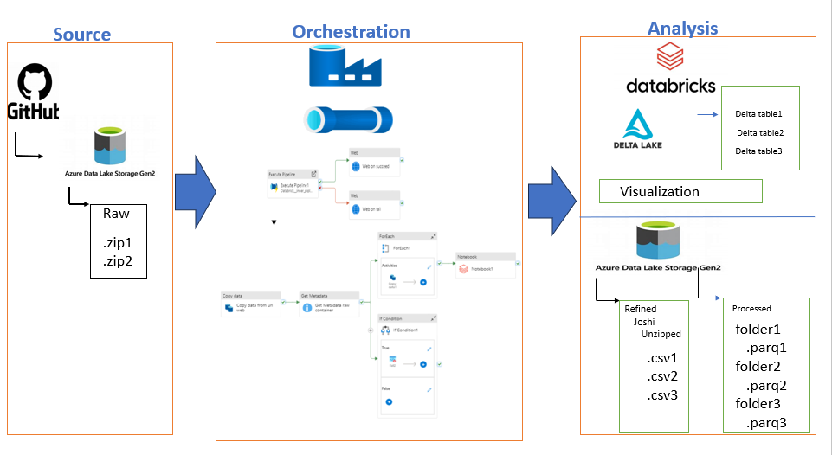

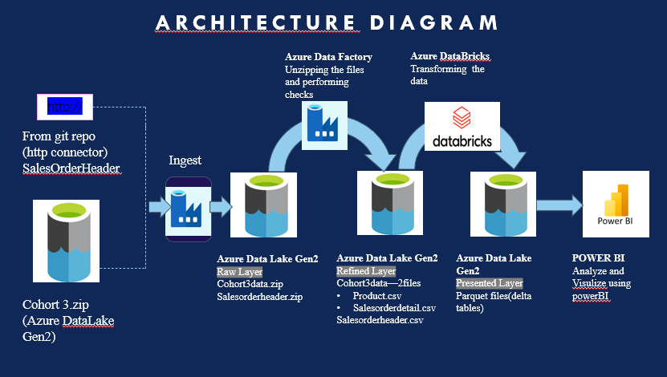

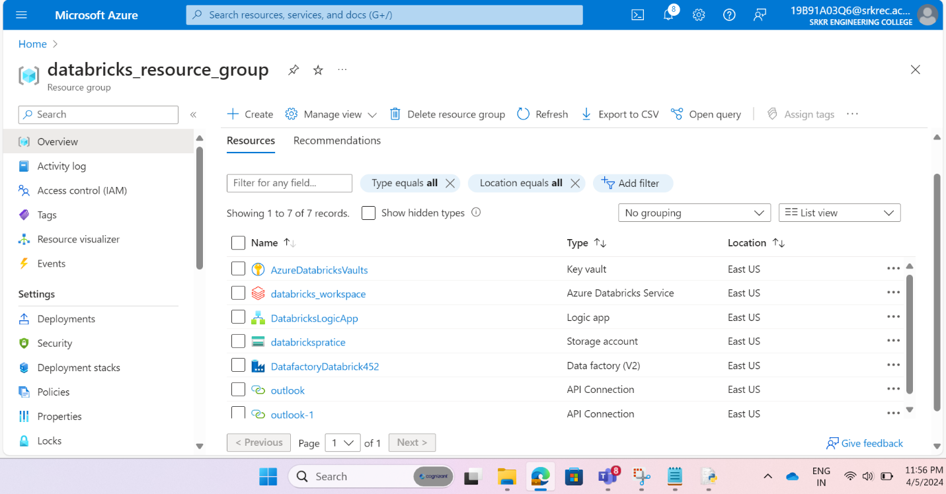

Step 1: create resource group “databricks_resource_group” which is used to hold resources.

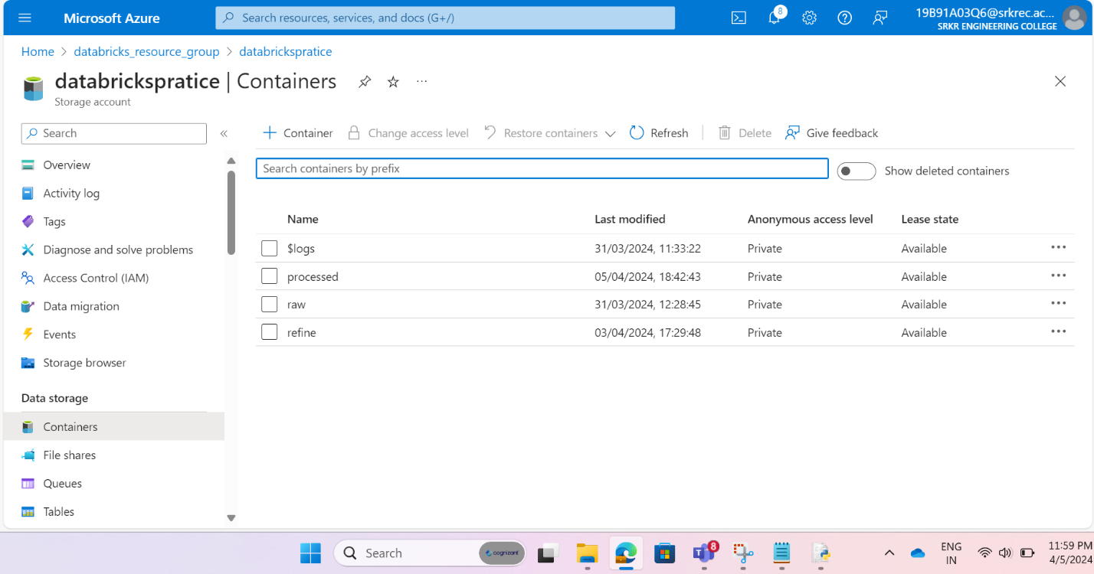

Step 2: Create storage account (Azure datalake ) with name “databrickspratice” for hierarchical namespace for storing raw data ,refined data, processed data in different folders inside containers.

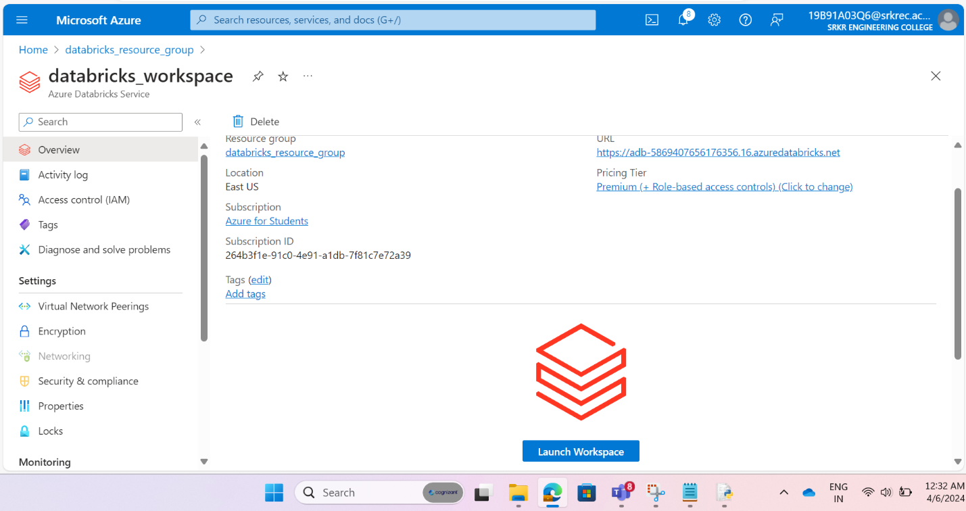

Step 3:Create data bricks workspace with name “databricks_workspace”.

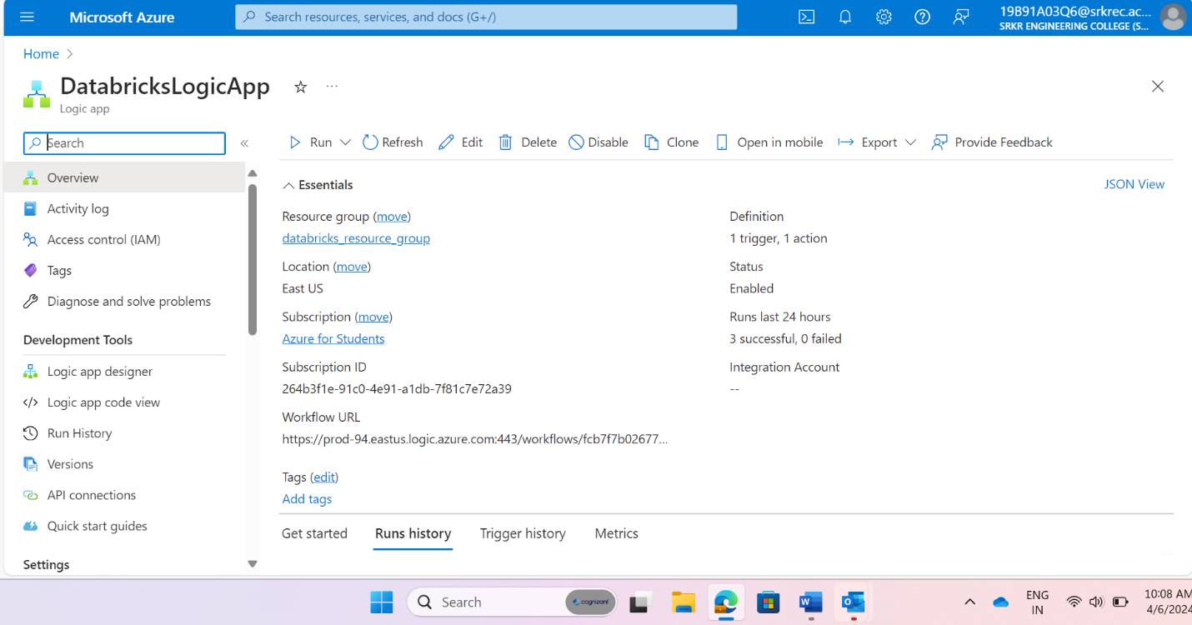

Step 4: Create logic app with name “DatabricksLogicApp”.

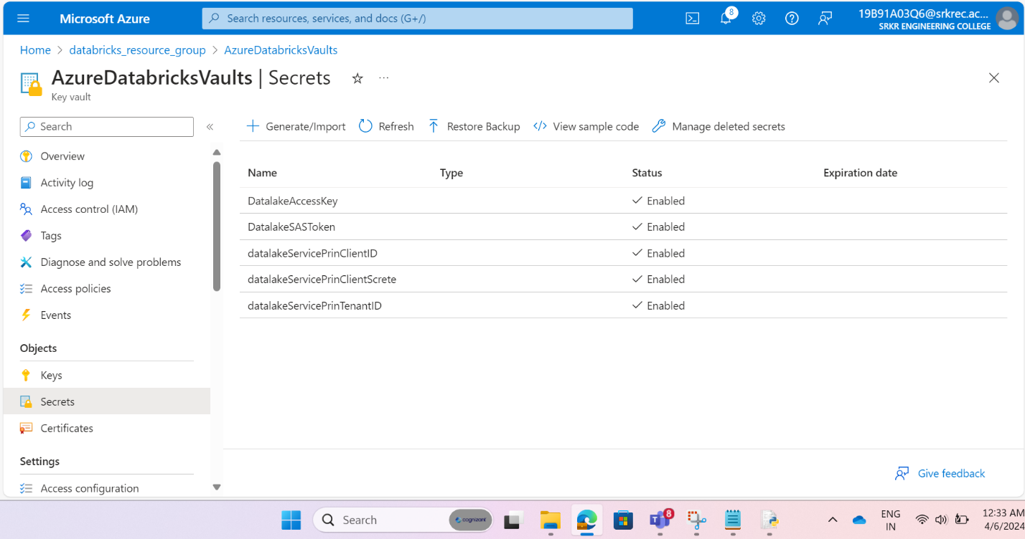Step 5: Create Azure key vault with name “AzureDatabricksVaults” to store secrets in key valuts for project .

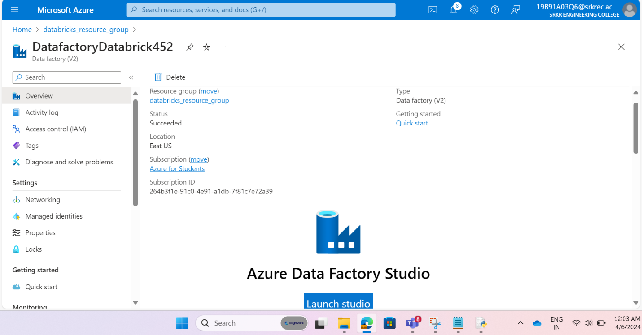

Step 6: Create data factory with name” DatafactoryDatabricks452” from creating pipelines and scheduling pipelines.

**Related to Azure DataFactory:**

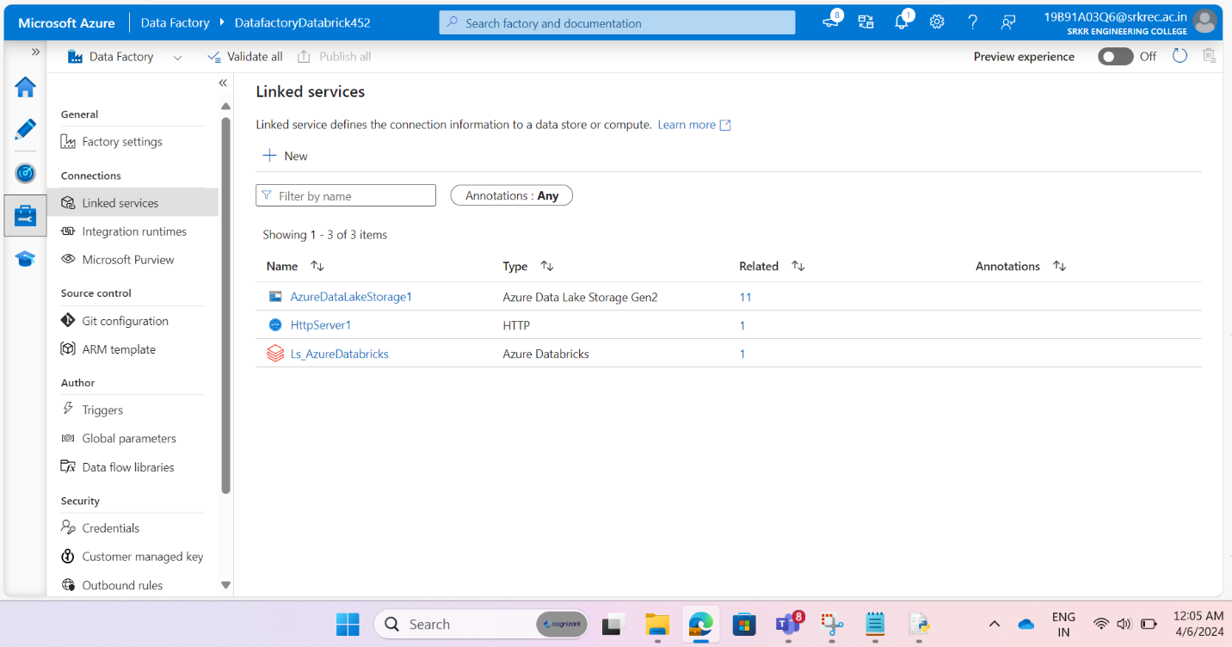

Step 7: Create Linked Services for data factory to external services provided in azure like data lake **(AzureDataLakeStorage**), data bricks **(LS_AzureDatabricks)** and http server **(HTTPSServer1).**

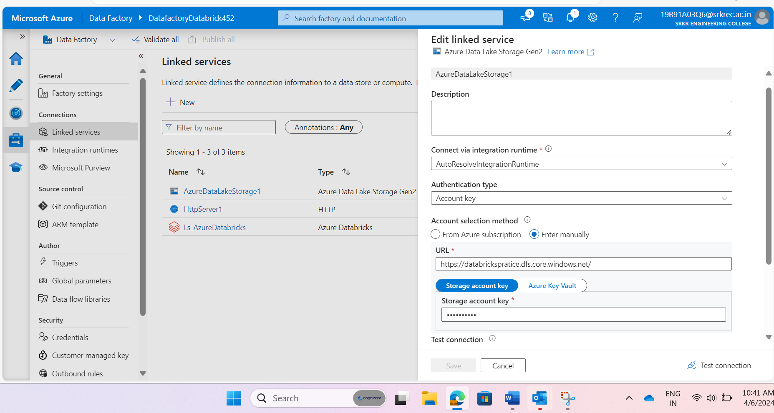

Step 8: Create Linked service between data lake and data factory with name “**AzureDataLakeStorage**”.

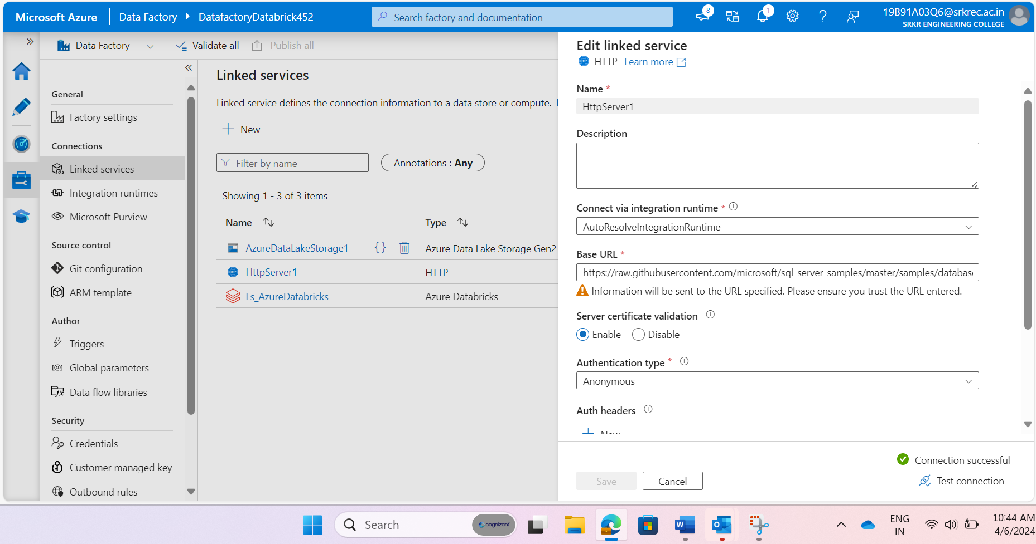

Step 9: Creating Linked Service between external data source to data factory with name “**HTTPSServer1**”.

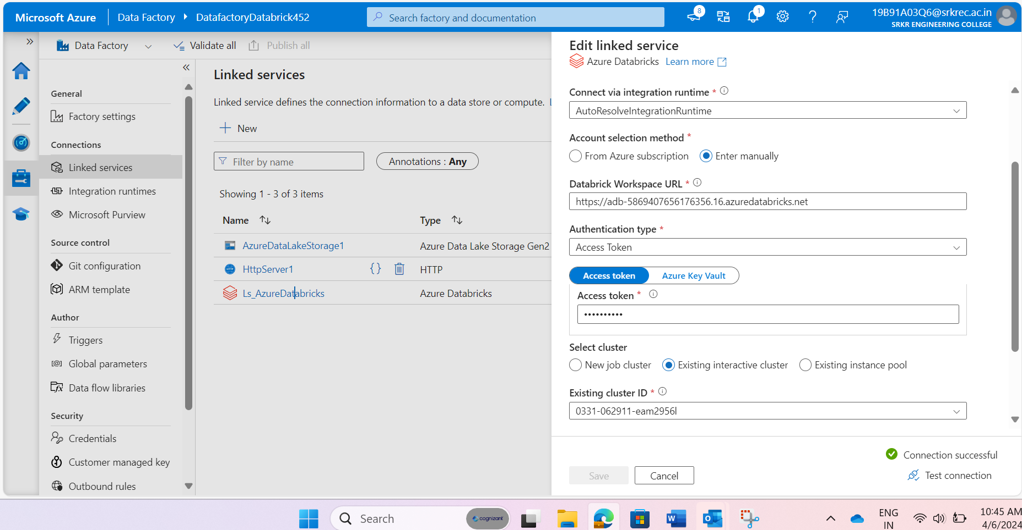

Step 10: Create Linked Service between data bricks and data factory with name “**LS_AzureDatabricks**”.

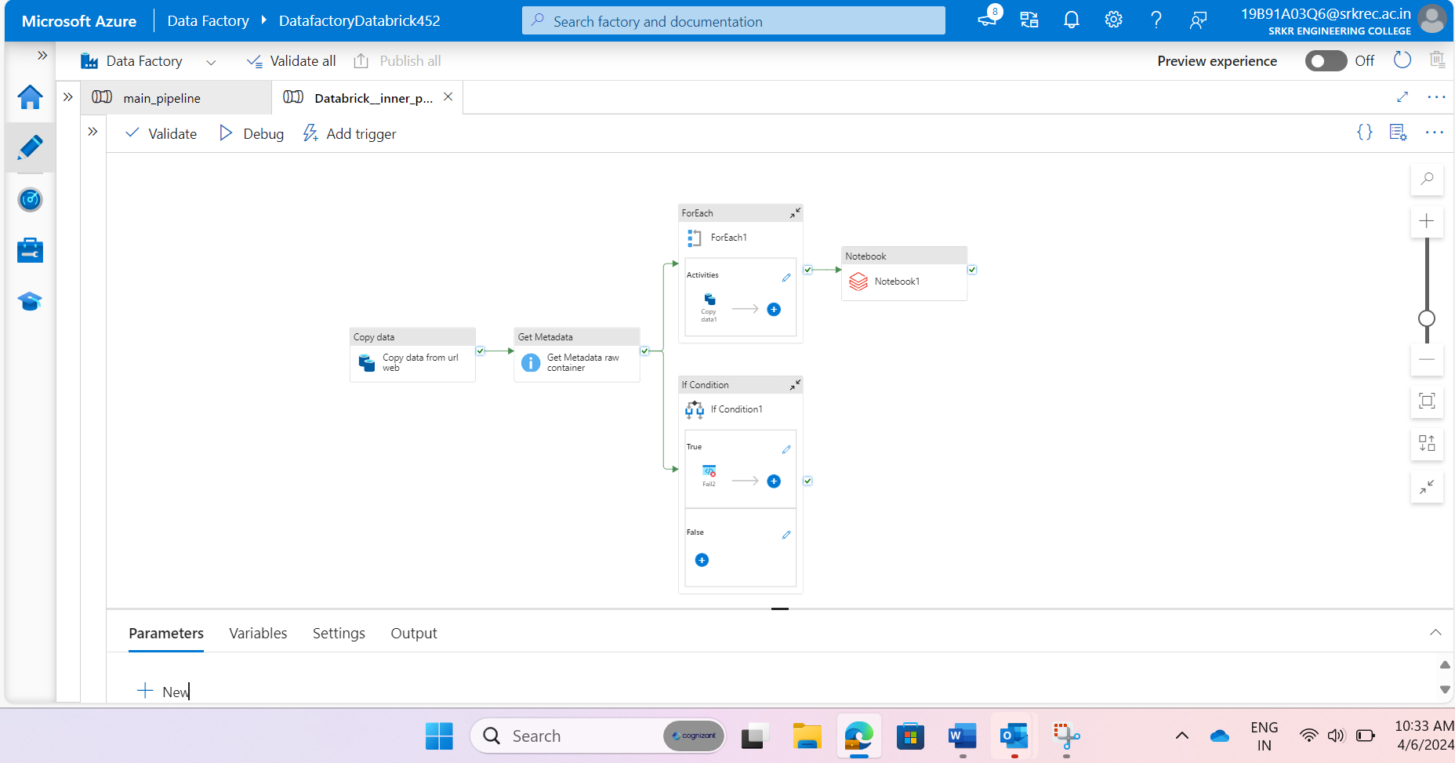

Above picture will show inner pipeline designed for data ingestion ,data transformation and data loading.

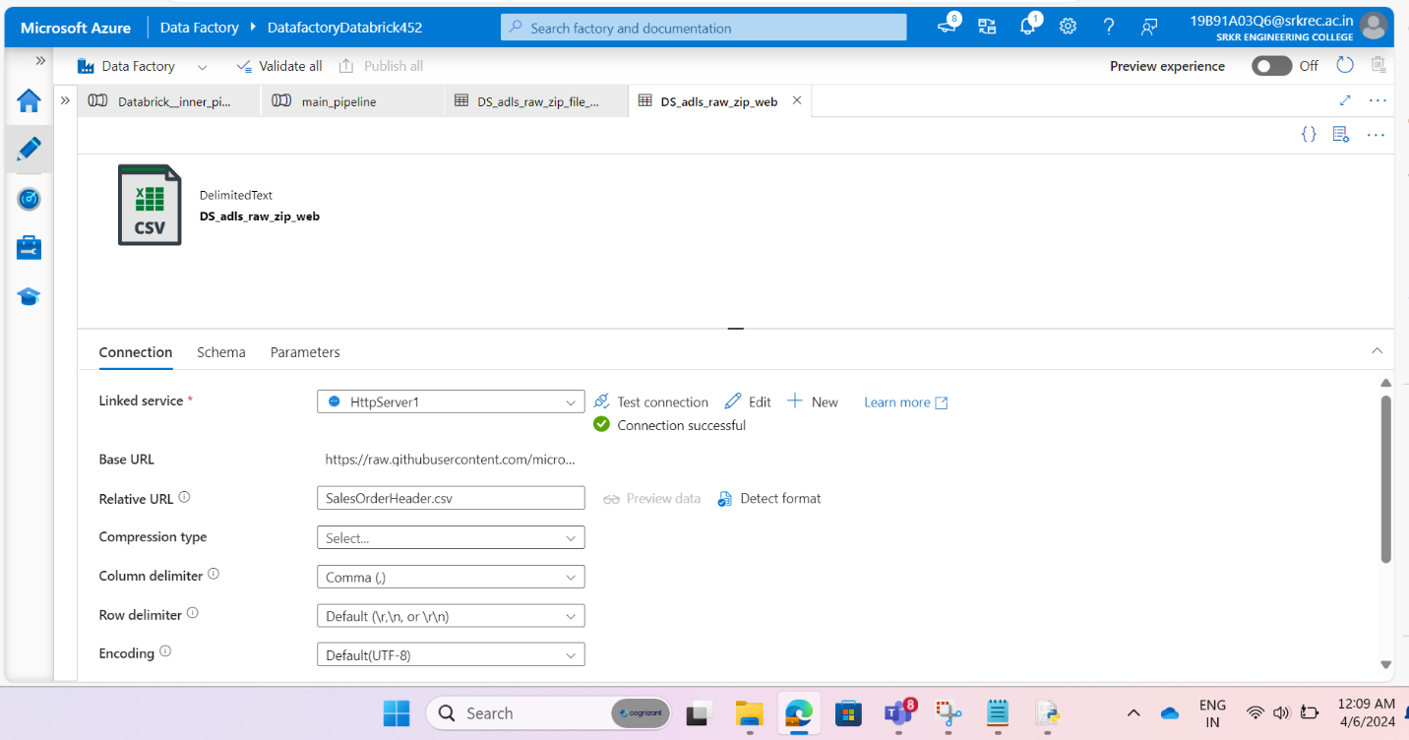

Step 11: Create source dataset for fetching data from https URL .

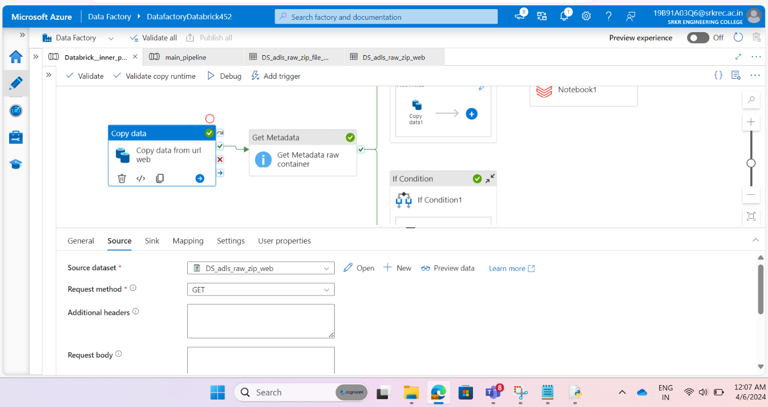

Step 12: given that **“DS_adls_raw_zip_web”** dataset for source side of copy data activity with name as **“Copy data from URL web”.**

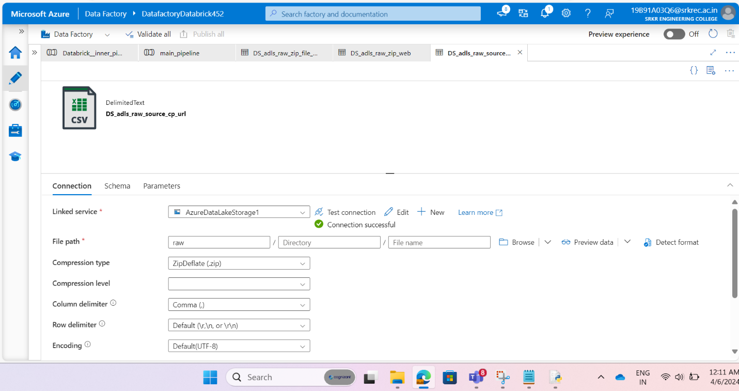

Step 13: Create sink data set for storing data set into raw container in data lake in zip format by giving compression type as (ZIP).

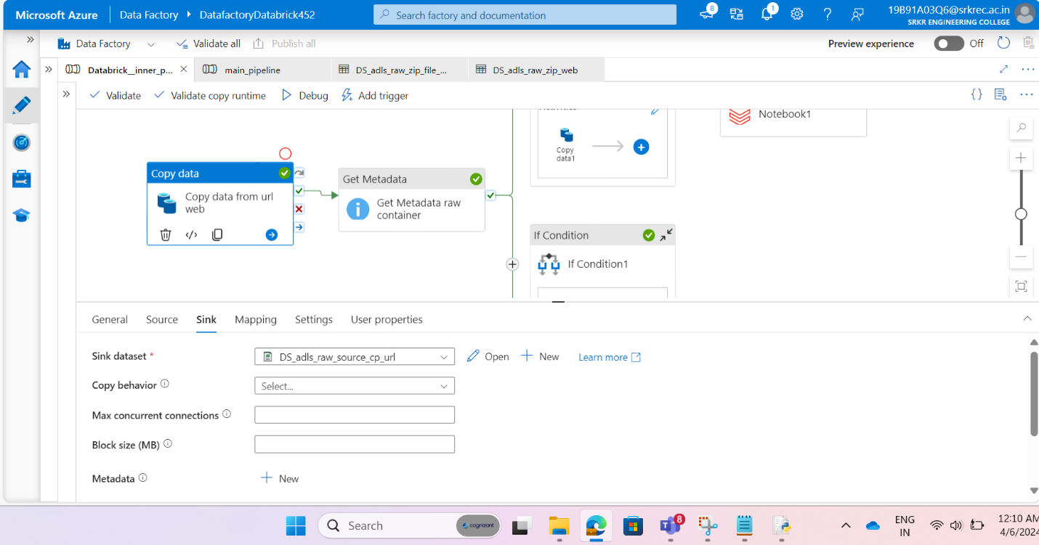

Step 14: given that **“DS_adls_raw_source_cp_url”** dataset for sink side of copy data activity **“Copy data from URL web”.**

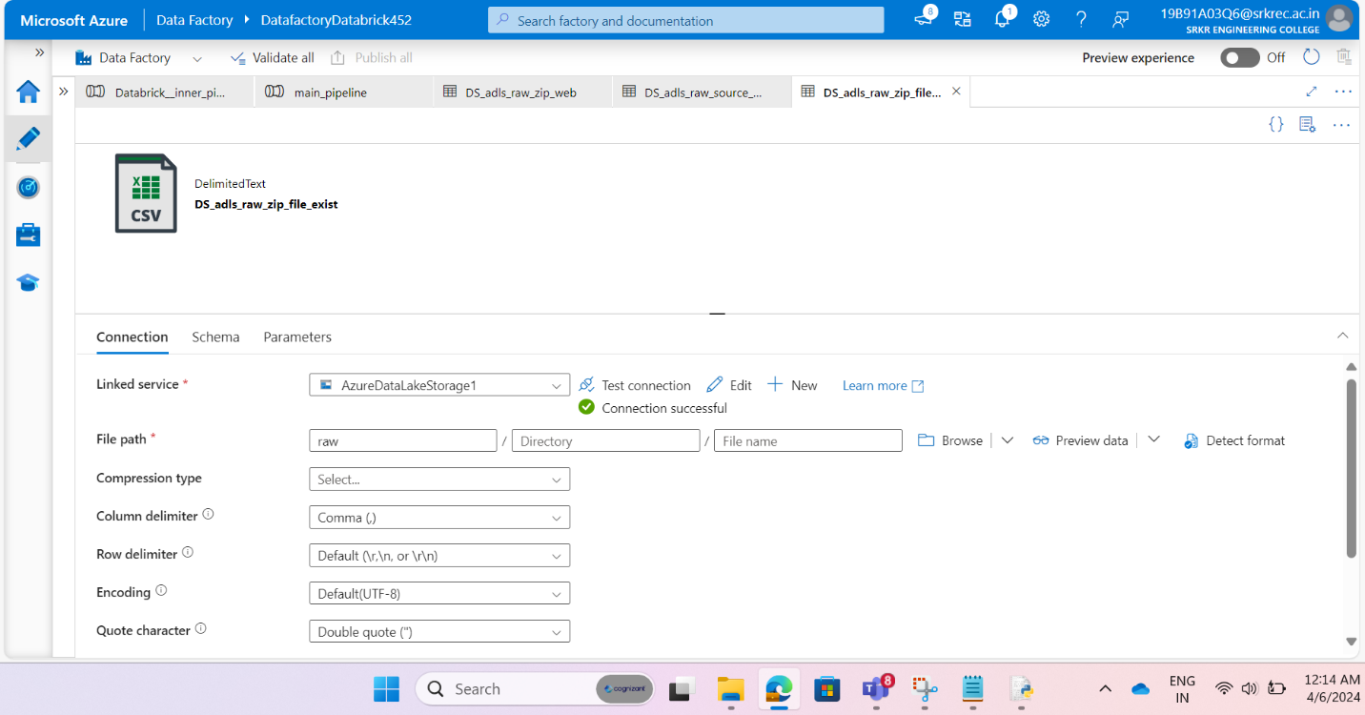

Step 15: Create dataset for get metadata activity to point out to raw container for feaching metadata about files and folders in that container.

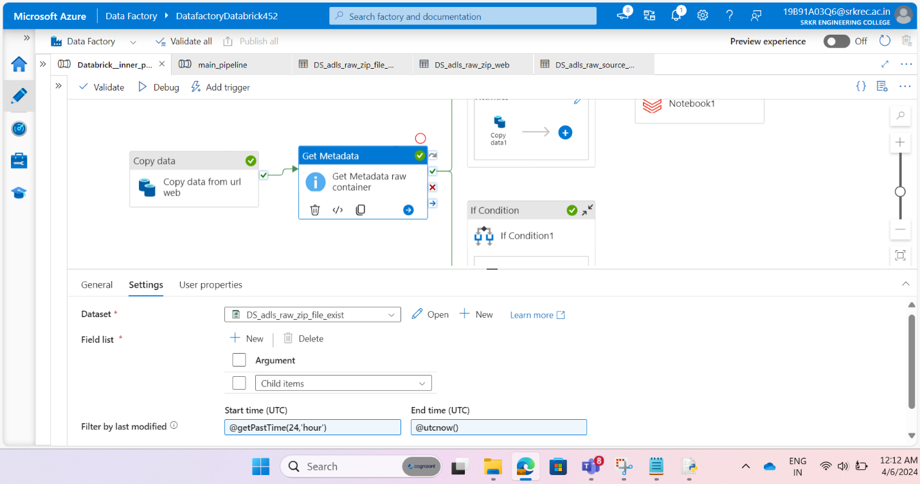

Step 16 : Given that “DS_adls_raw_zip_file_exist” dataset for picking childitems of files in raw containers within 24 hours from present time when pipeline start .

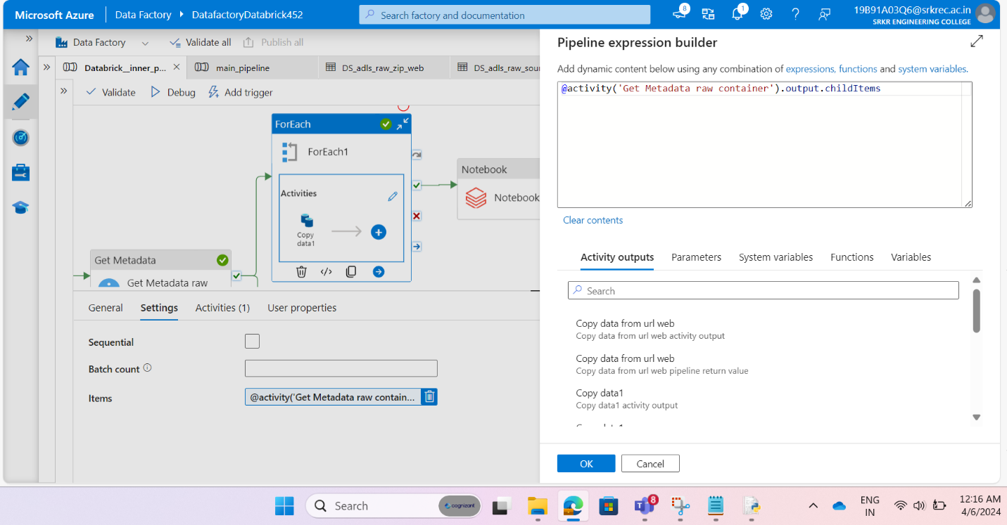

Step 17: Drag and drop for each activity for iterate over those child items pick by get metadata. Connect get metadata output with for each activity.

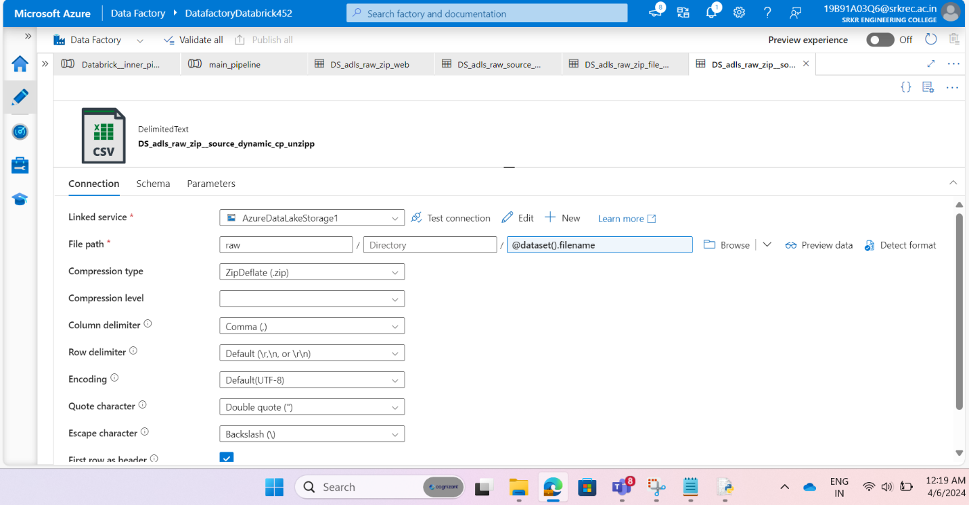

Step 18: Create source dataset for copy activity inside for each activity by passing file name dynamically by creating parameter with **“filename”** and passing value **“@dataset().filename”** at dataset level dynamically and giving compression type as .Zip .

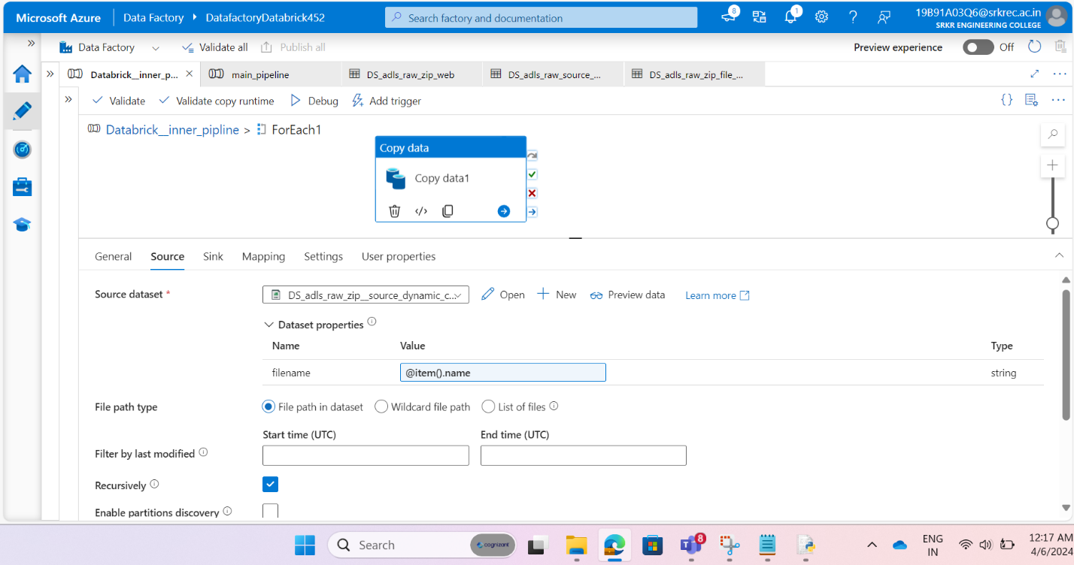

Step 19: Given that “**DS_adls_raw_zip_source_dynamcially_cp”** dataset at source side to copy data activity inside for each activity.

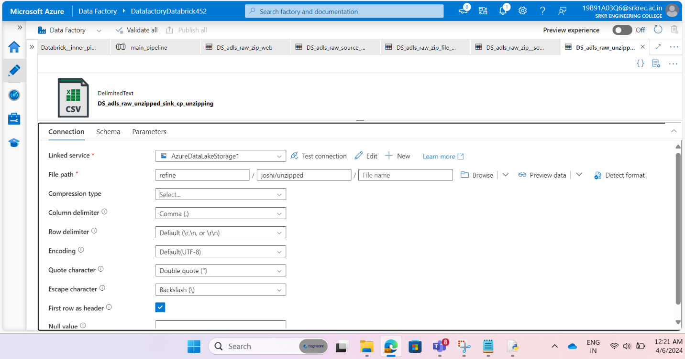

Step 20: Create dataset for sink side of copy data activity inside for each activity for copying zip file data from raw container to refine container inside folder name **“joshi/unzipped”** by unzipping files and keeping only **.csv files** inside refined container.

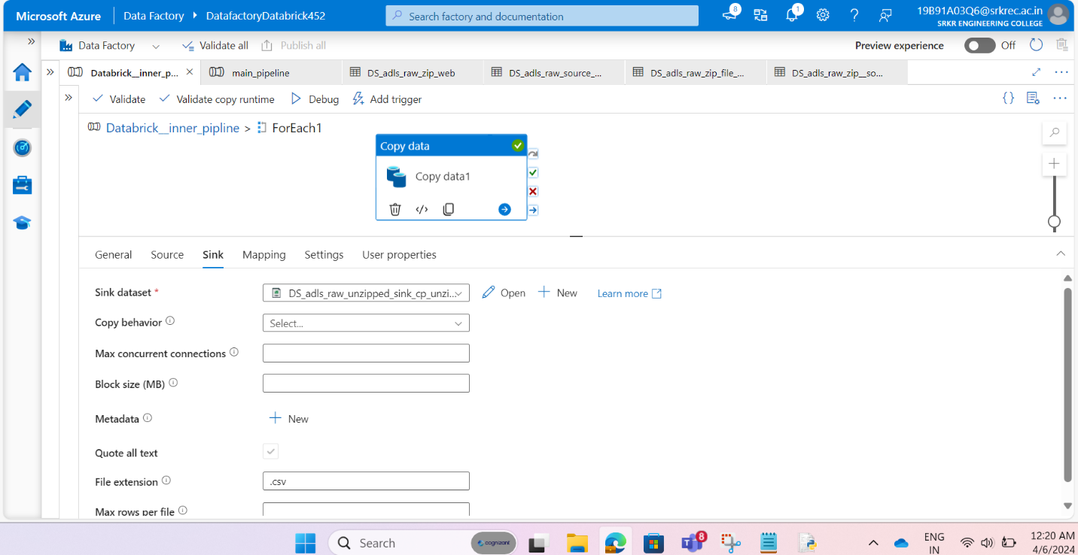

Step 21: given that **“DS_adls_raw_unzipped_sink_cp”** dataset to sink side of copy data activity inside for each activity.

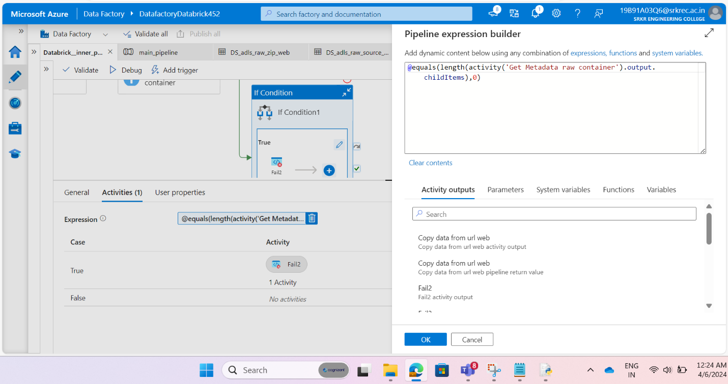

Step 22: Drag and drop if activity for checking child items length return by get metadata activity by giving condition like above it will check whether child item length is equals to zero or not.

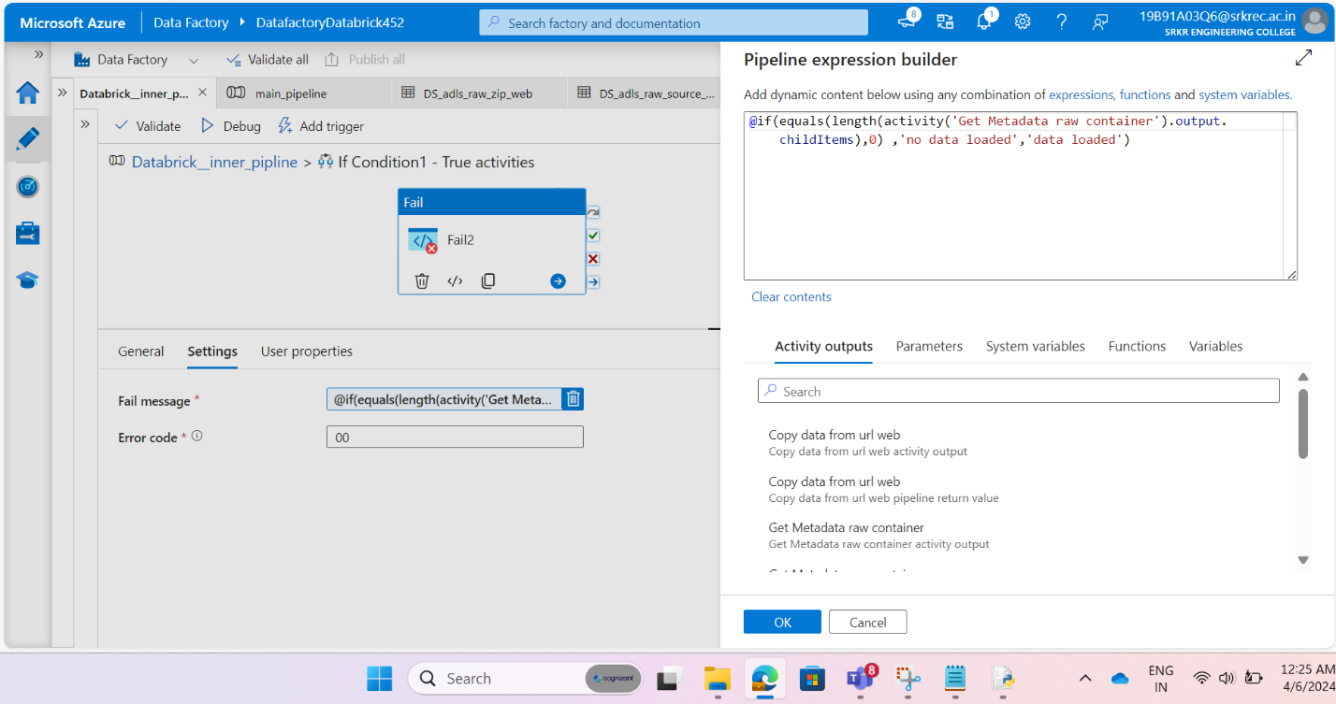

Step 23: Drag and drop Fail activity inside if condition while condition is true fail activity will work. Check for child item length whether zero or not depending upon that fail activity will fail pipeline when condition is true.

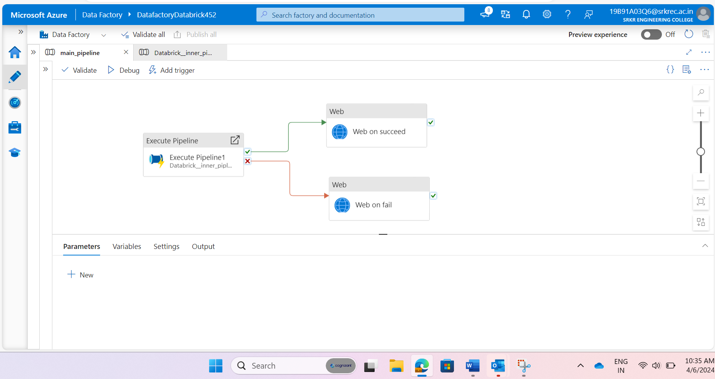

Step 24: Create another main pipeline with Execute pipeline activity, web activity.

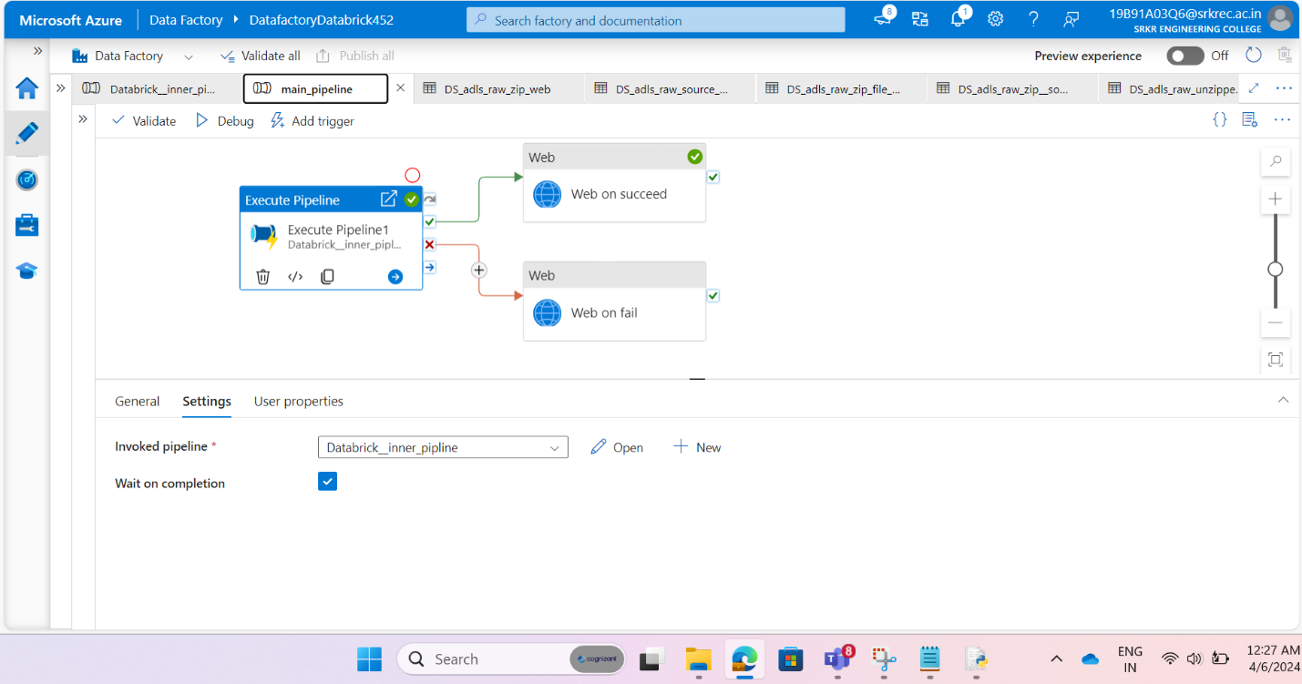

Step 25: given another pipeline to this activity which is nothing previous pipeline with name **“Databrick_inner_pipelin”.**

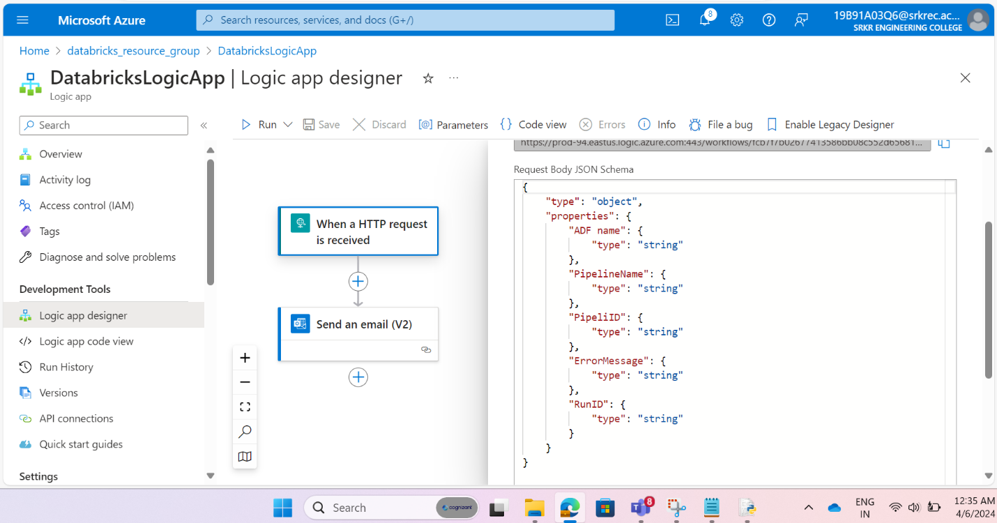

Step 26: Design log app for triggering mail when pipeline fail or on pipeline succeed by passing Json format which are to be appear in mail like pipeline id, ADF name, pipeline name, error message.

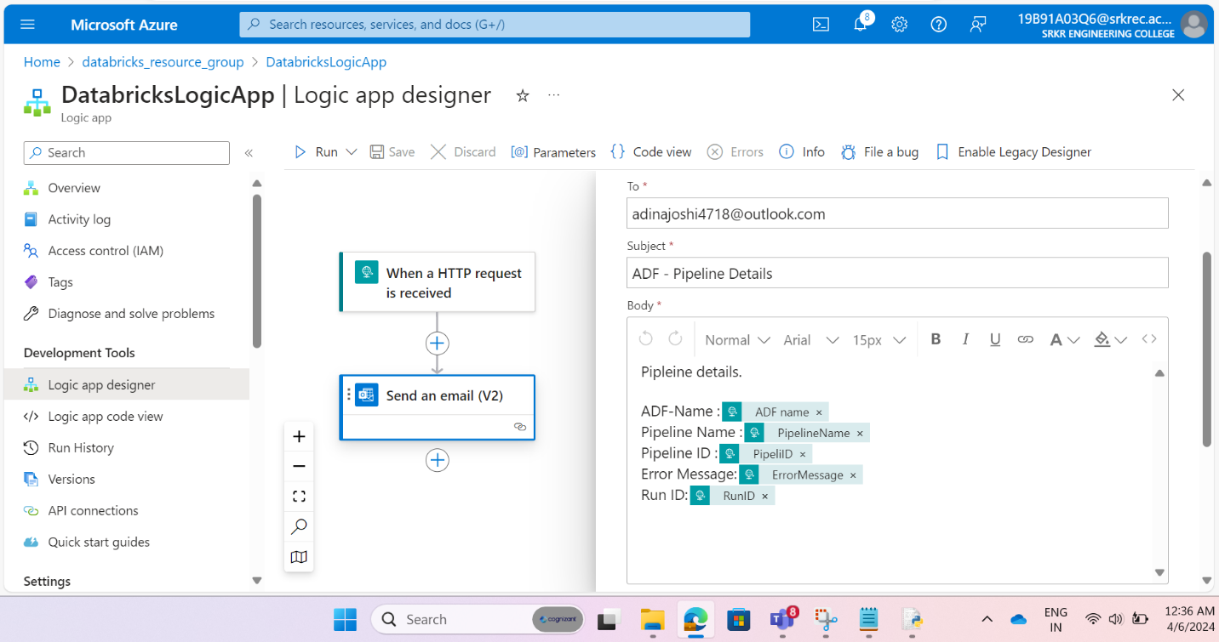

Step 27: Design custom mail by giving personal mail id and craeting body with requried details reagarding pipeline fails details.

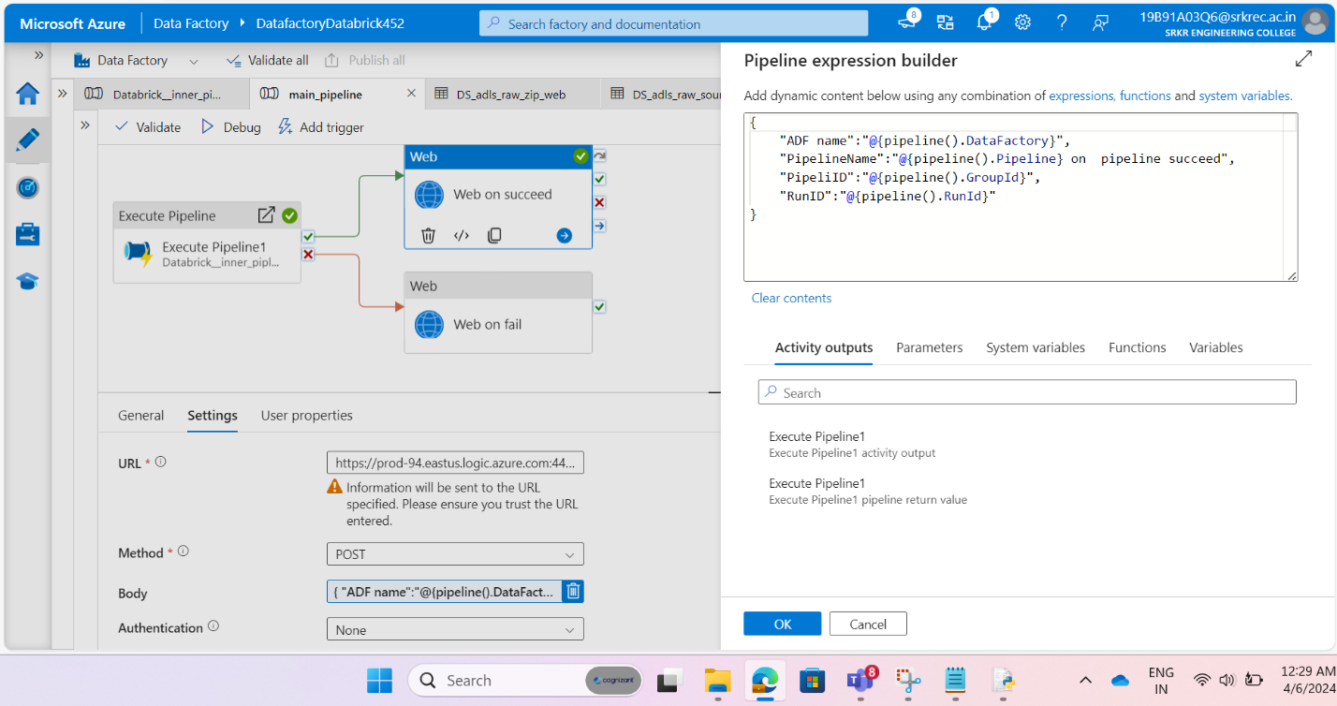

Step 28: given ADF name, pipeline name, pipeline id, Run id dynamically to https request to trigger mail in logic app on pipeline succeed.

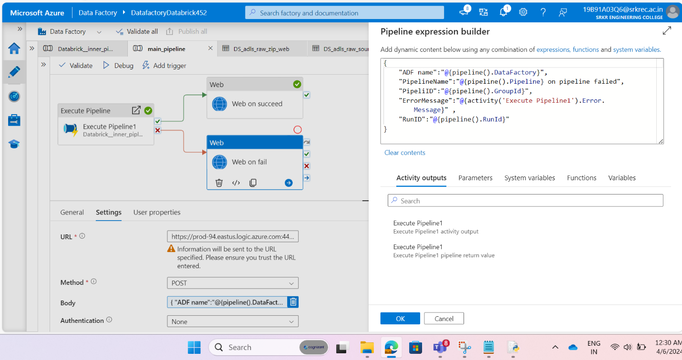

Step 29: given ADF name, pipeline name, pipeline id, Run id, error message dynamically to https request to trigger mail in logic app on pipeline fail.

**Related to Data bricks:**

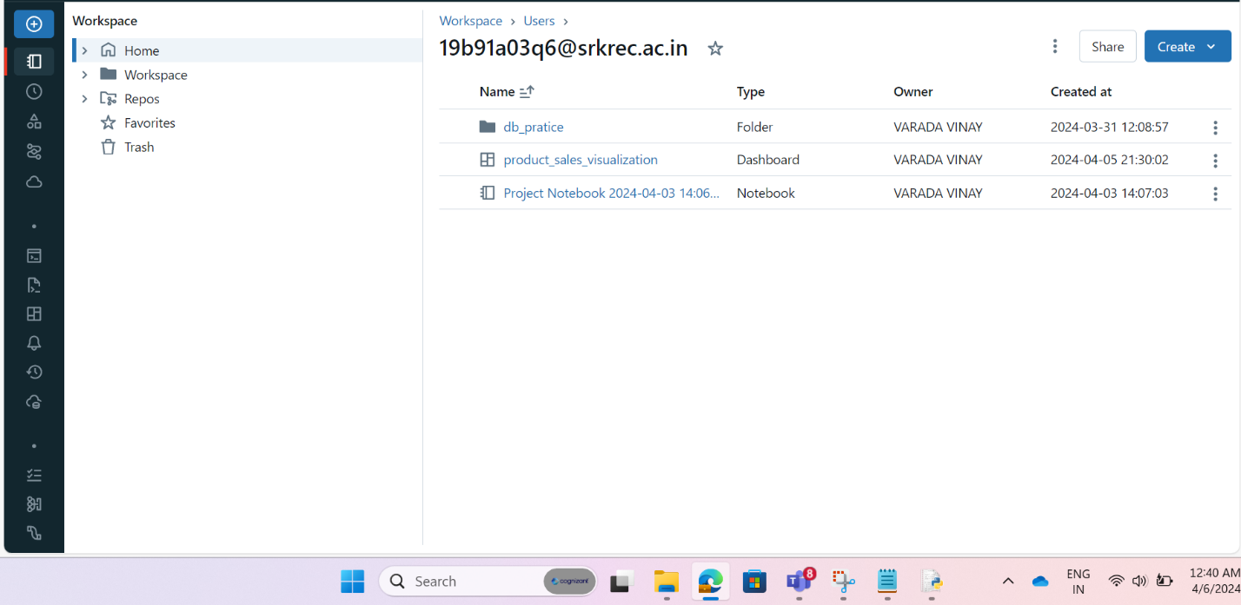

Step 30: Create workspace for doing data cleaning and data transformation on raw data.

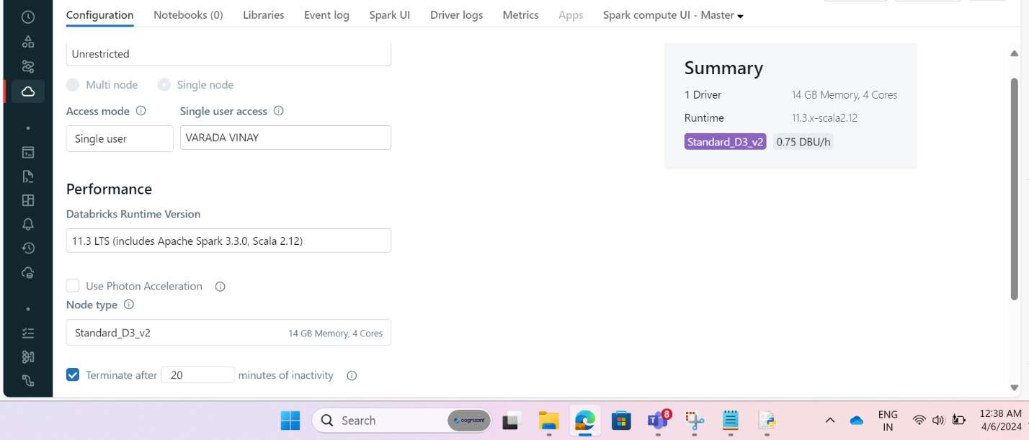

Step 31: Create cluster with single node for running queries written in notebook and to give output.

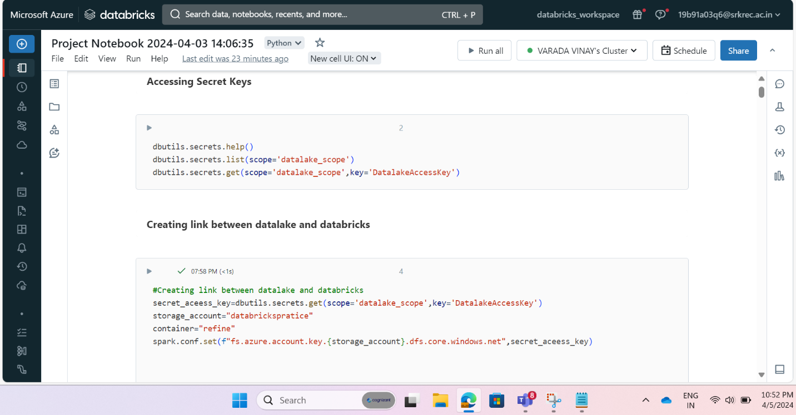

Step 32: By using above code we can fetch secrets creating in data bricks and we can create link and authentication for data lake to data bricks.

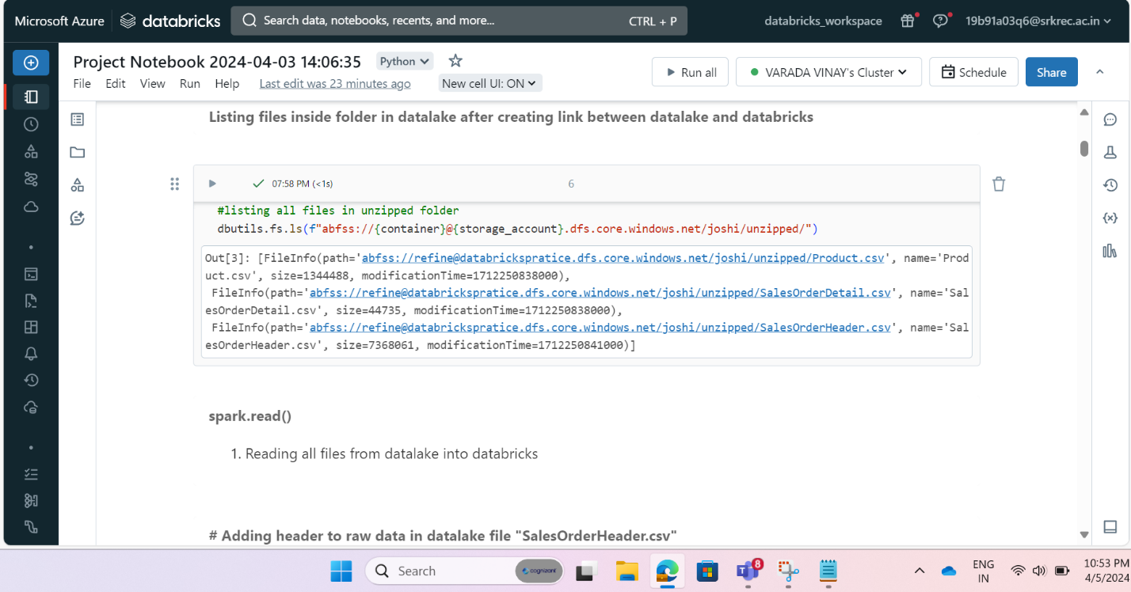

Step 33: Above code is used to fetch files from data lake into data bricks to picks file for cleaning and transformation.

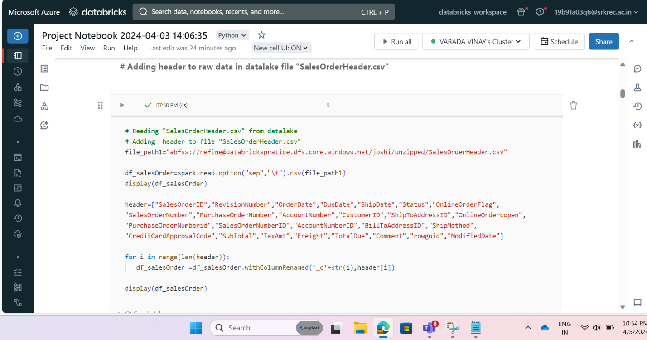

Step 34: Above code in used to read raw file from data lake and add header to that raw file.

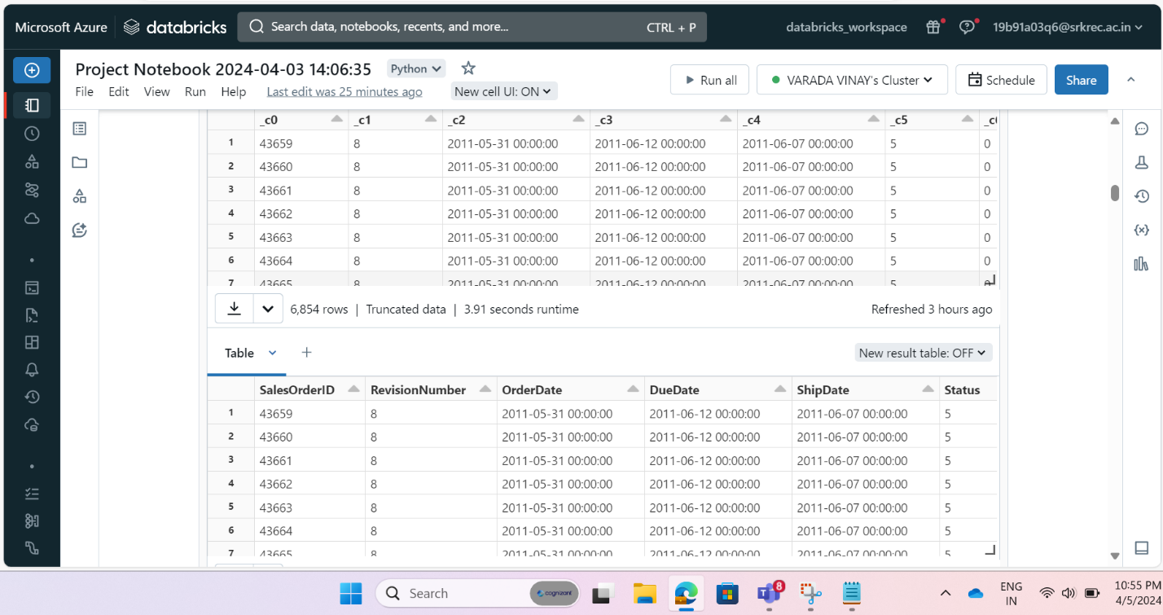

Step 35: Above picture will show the output for above code to add header to raw file.

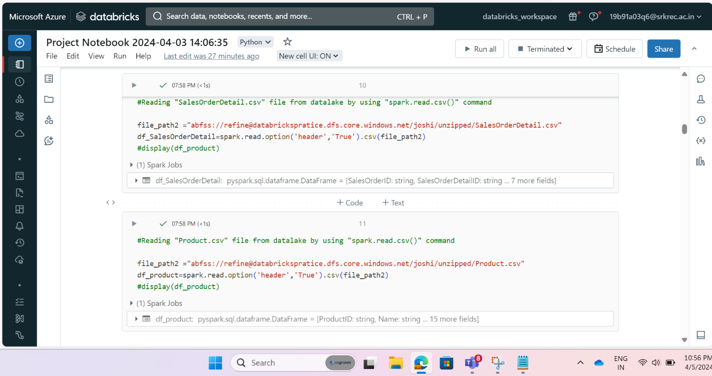

Step 36: Above code is used for reading csv files from datalake into data bricks.

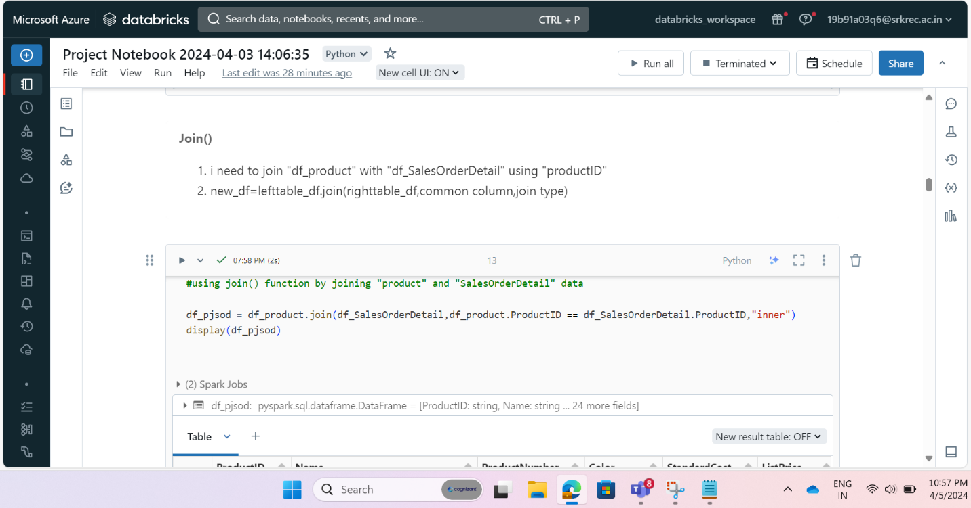

Step 37: Above code is used for apply join between to datasets “product” and “salesorder details” files.

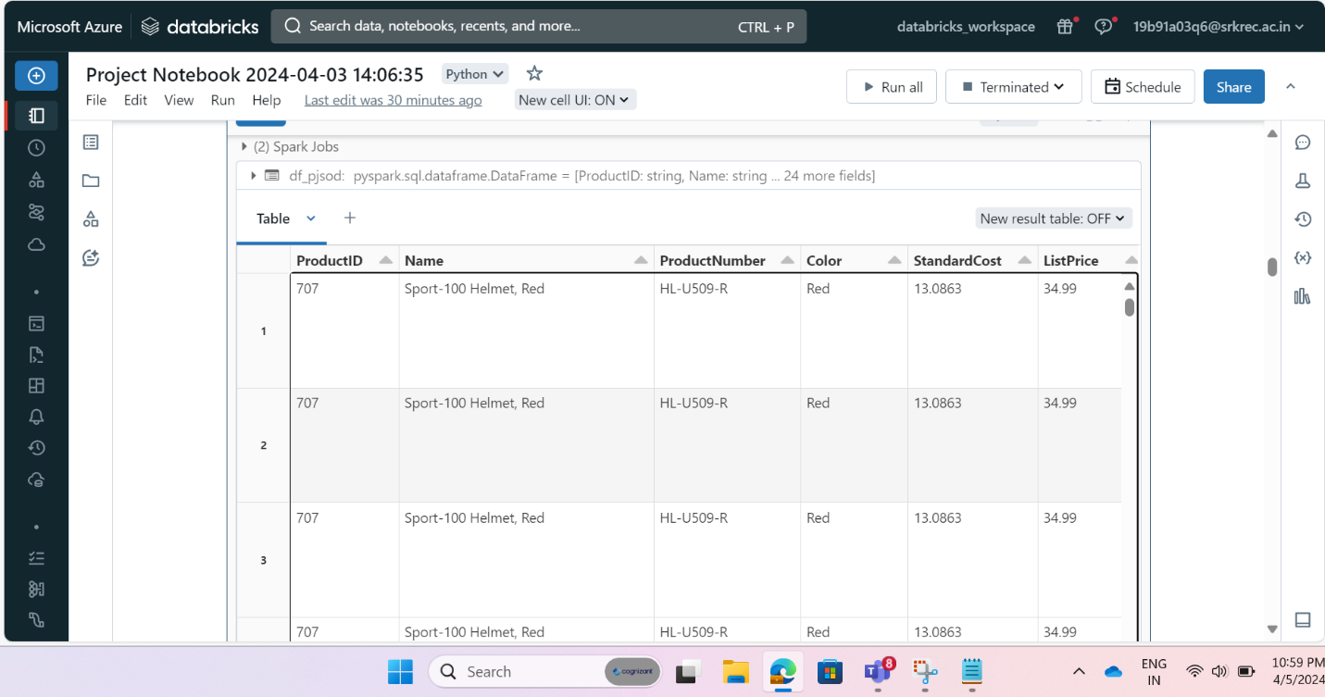

Step 38: After applying join by above code the output appear is like this.

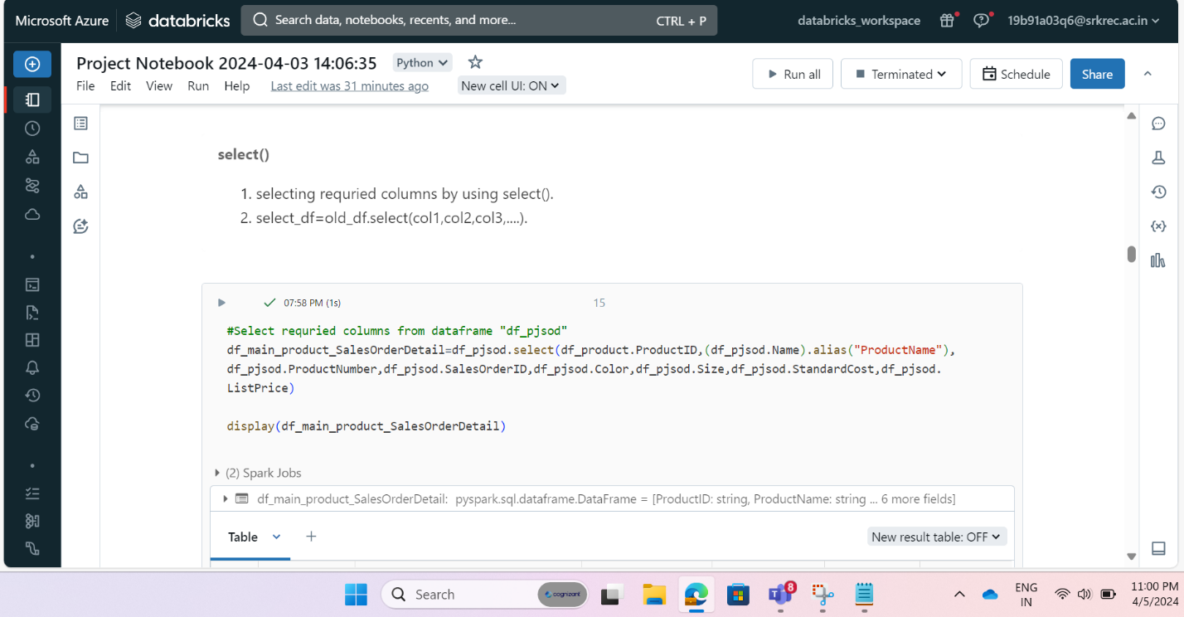

Step 39: Above code is to select requried columns from that join table for our data cleaning and data transformation .

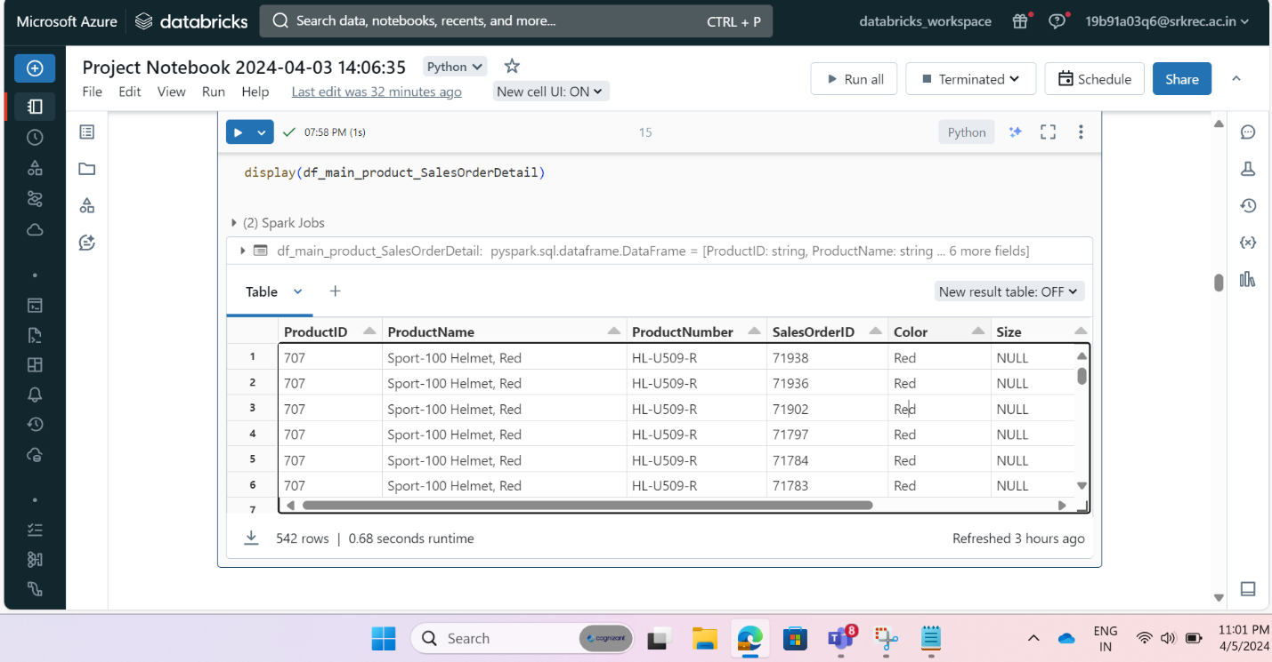

Step 40: After selecting required columns by using above code we got this output.

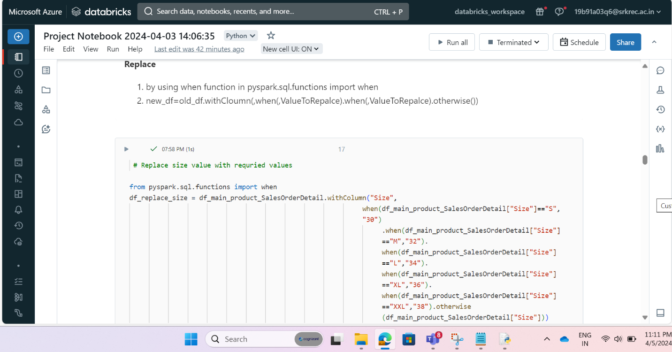

Step 41: Above code is used for cleaning data by replace size values which are letter with a number.

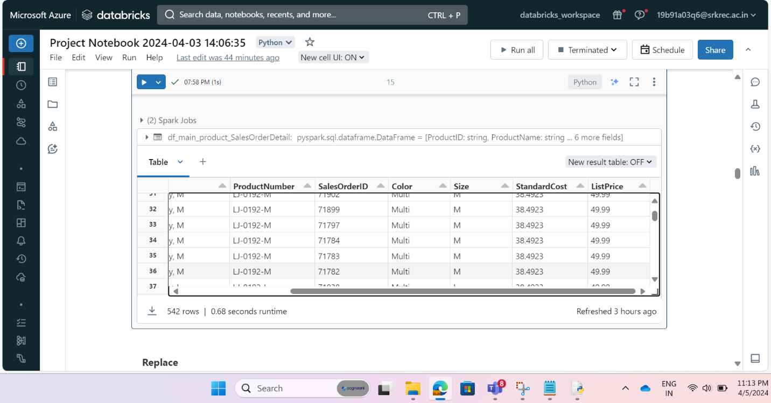

Step 42: picture is showing size column data before applying transformation.

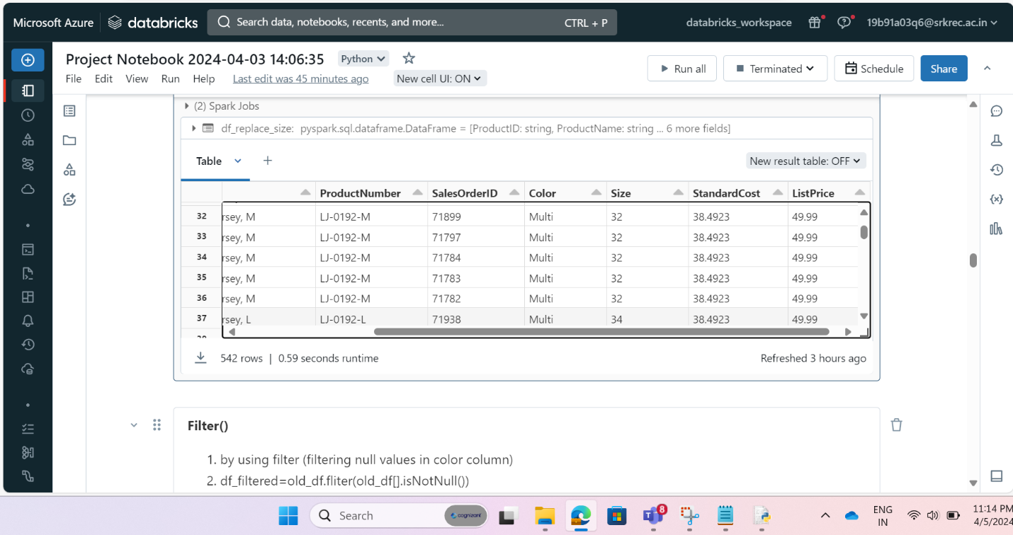

Step 43: picture is showing size column data after applying transformation.

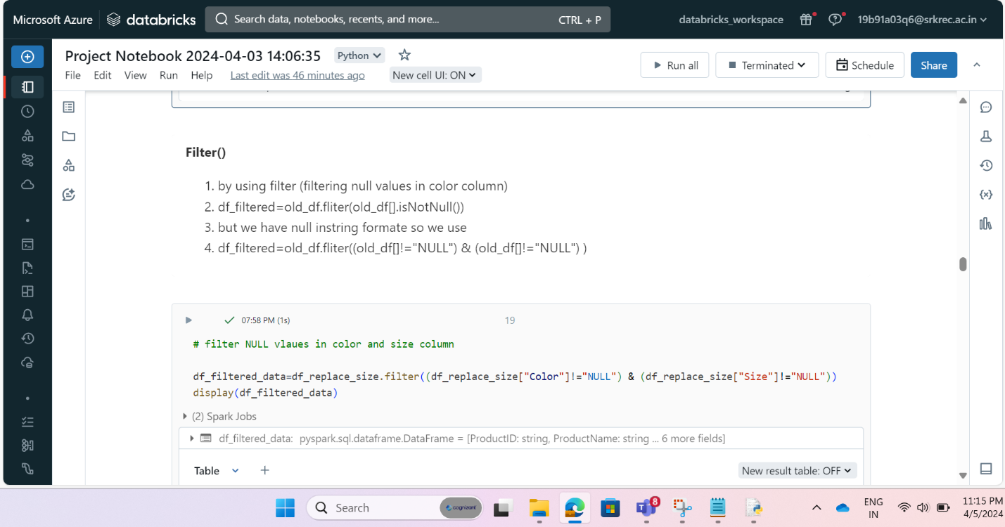

Step 44: Above code is used for filtering color,size column recorders whivh are NULL.

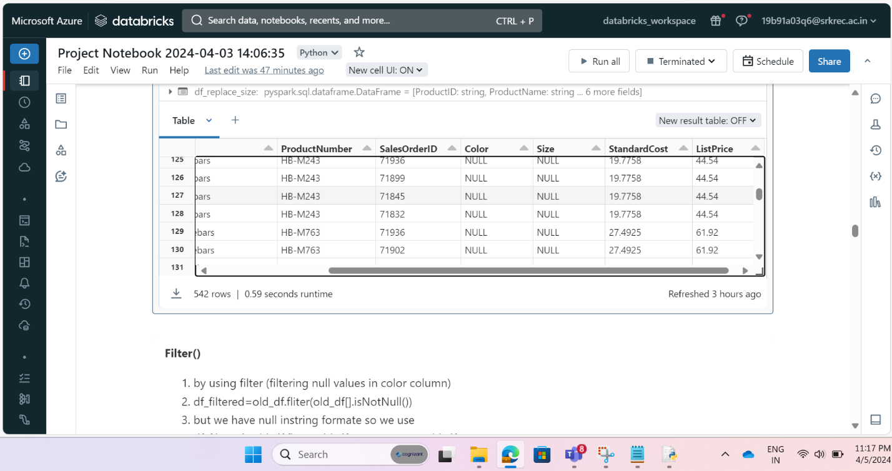

Step 45 : Above picture shows output before filtering null values.

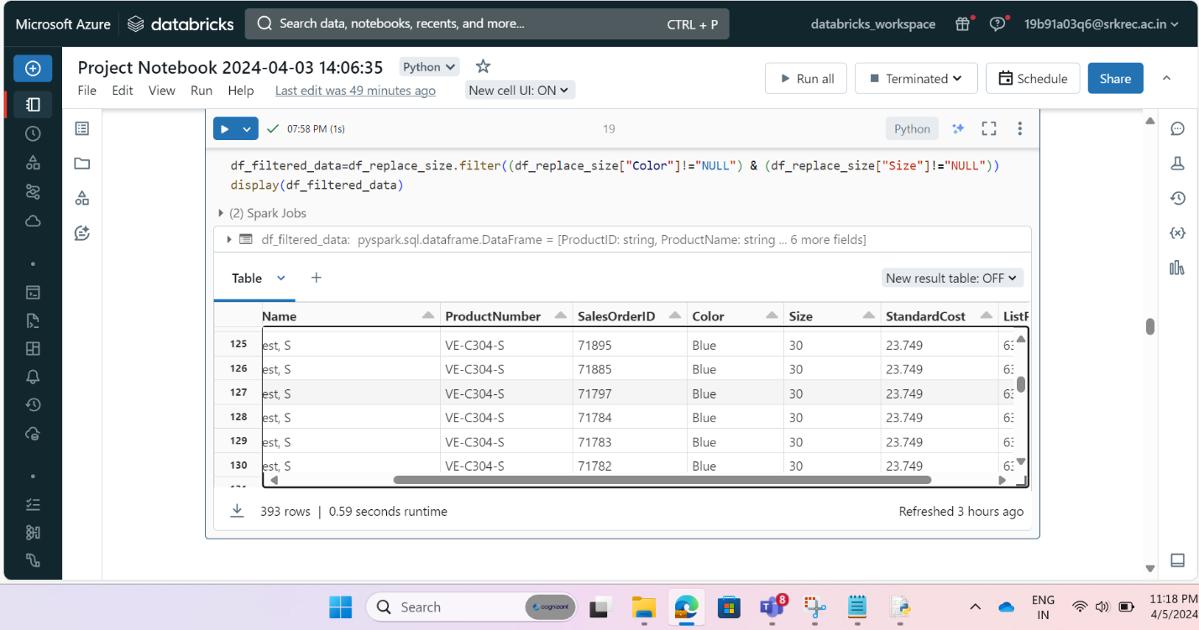

Step 46: Above picture shows output after filtering null values.

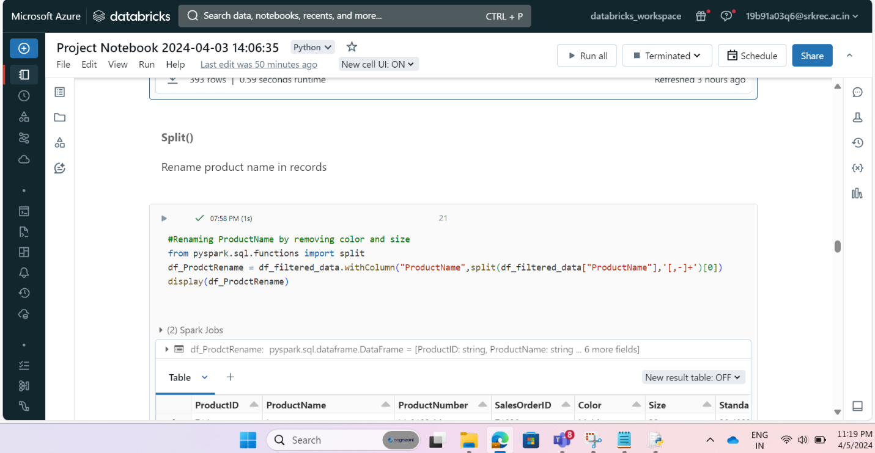

Step 47: Above code is to clean product name is useful manner by using split () function in pyspark.

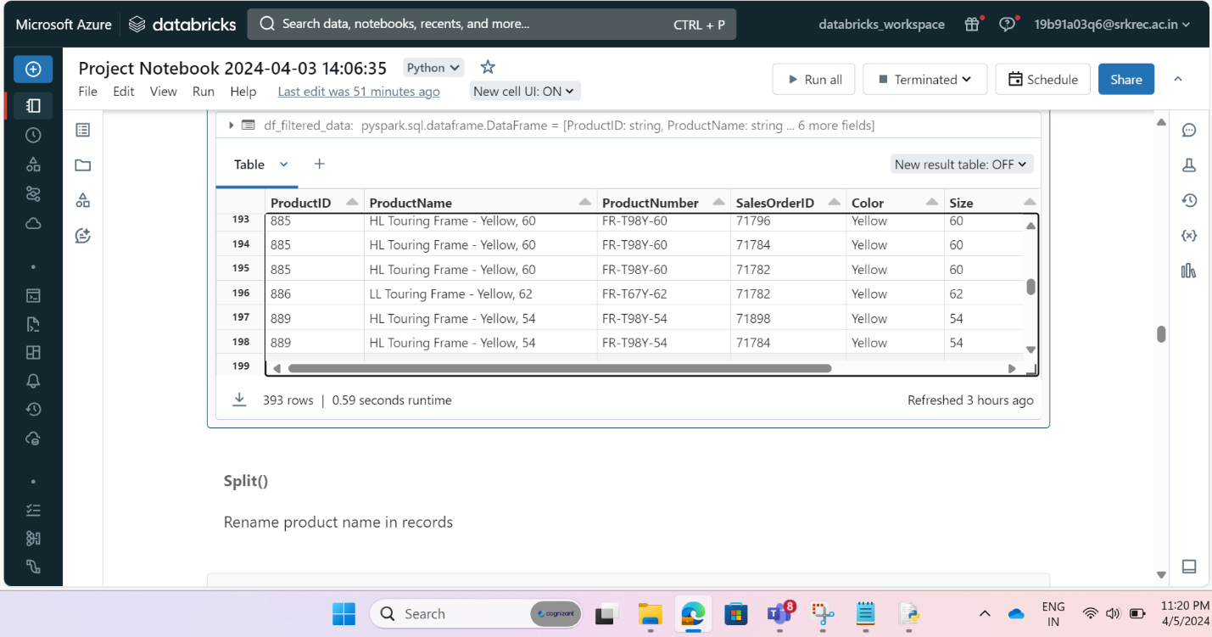

Step 48: Above picture shows output before applying split() function.

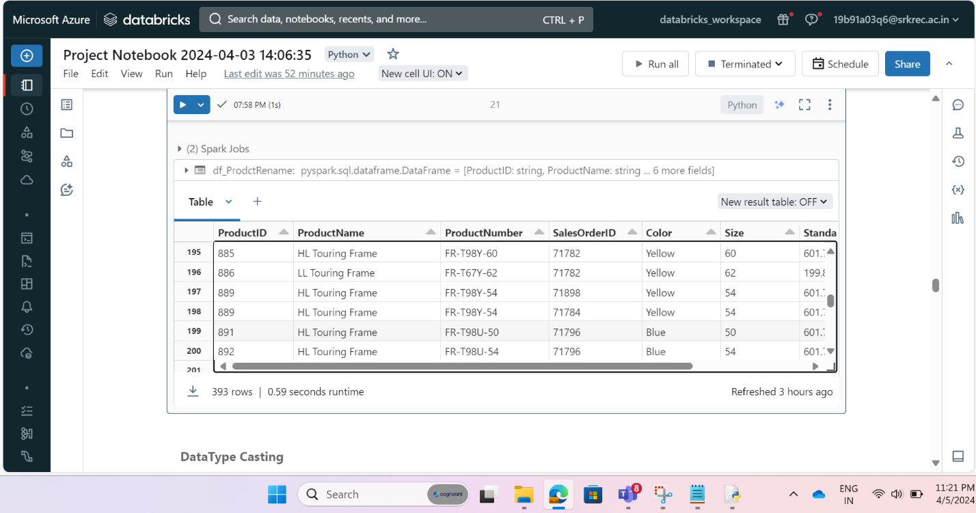

Step 49: Above picture shows output after applying split() function.

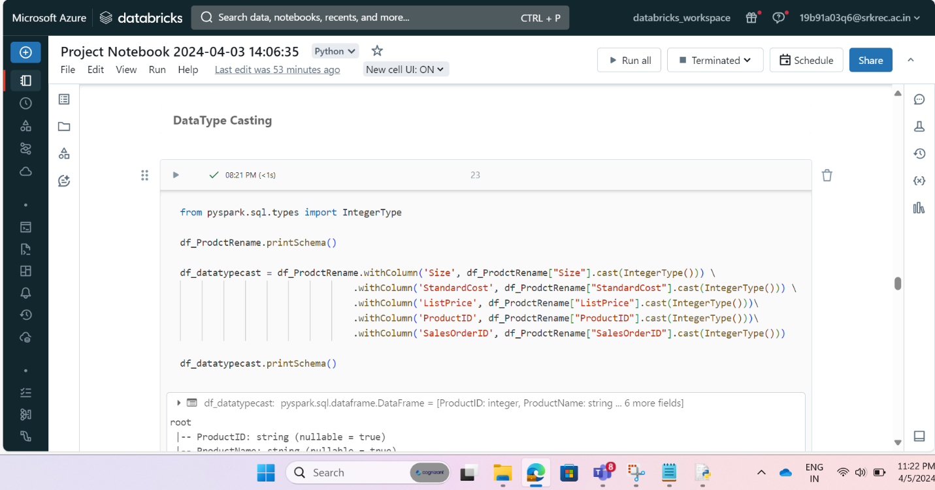

Step 50: above code is to type cat datatype form string to integers.

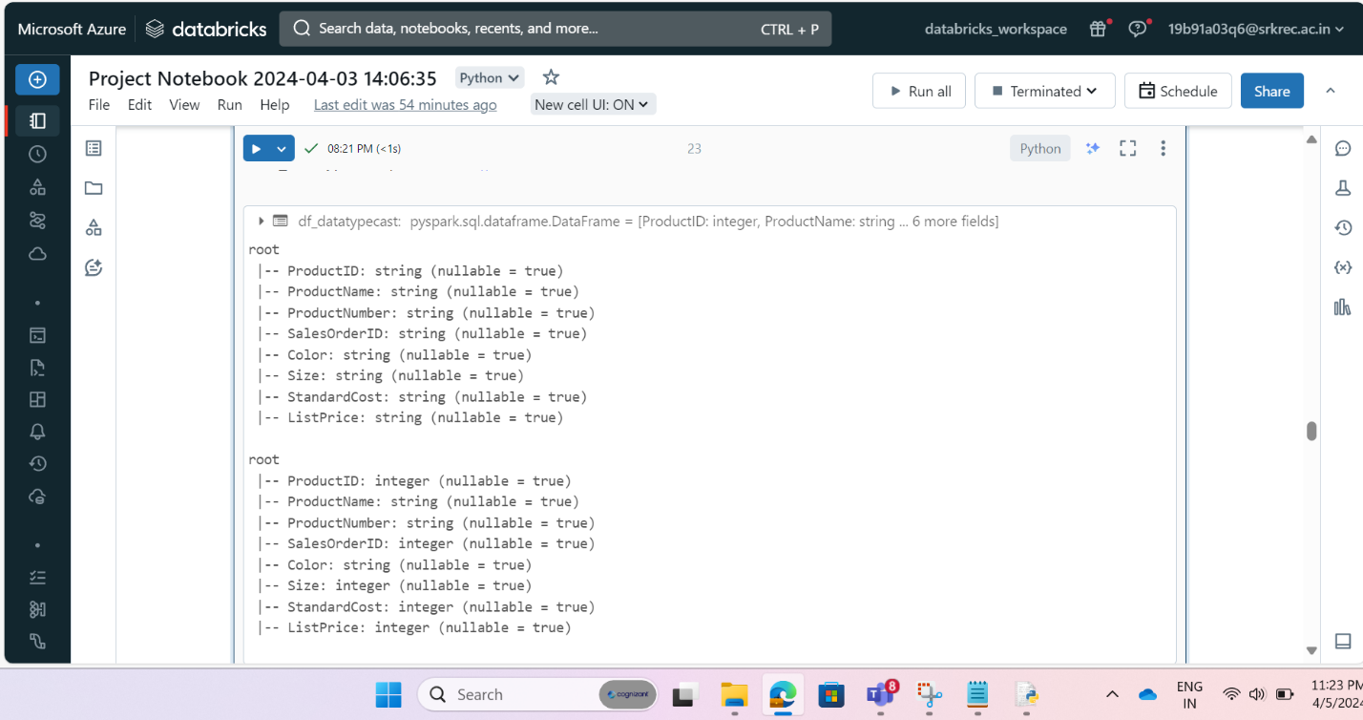

Step 51: result of above code after and before type casting schema.

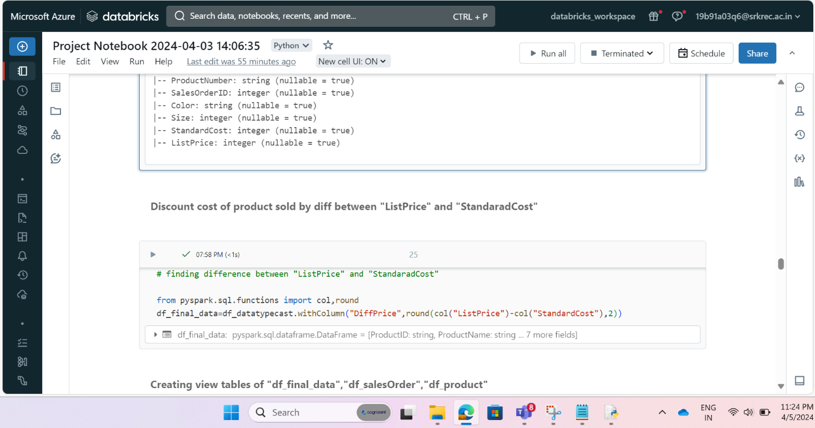

Step 52: Find different between listprice and standardprice .

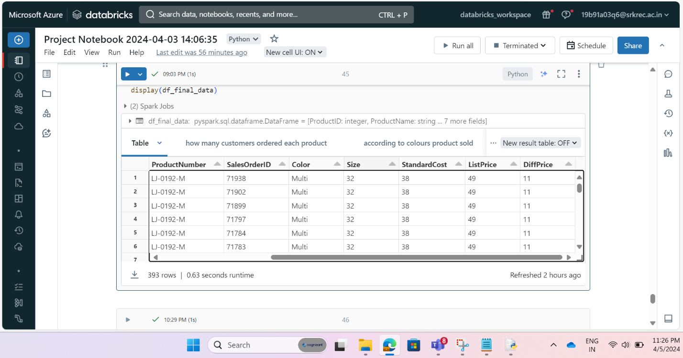

Step 53: Output for above code using to find difference between listprice and standardprice.

**Creating delta tables (manage tables) in data bricks in hive meta store which are stored in DBFS.**

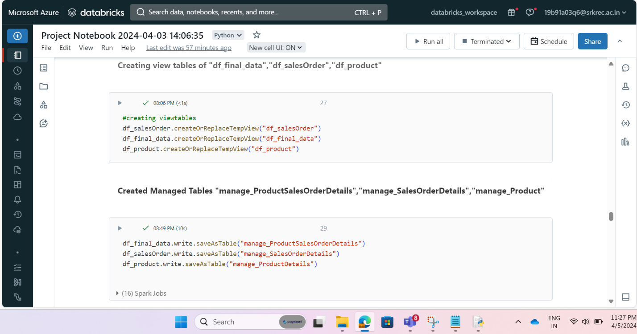

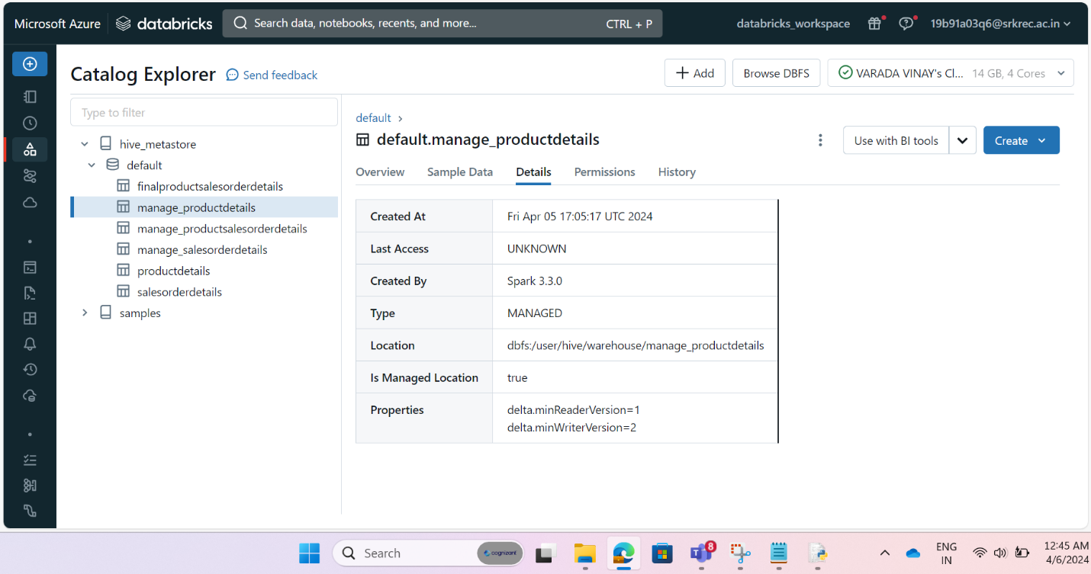

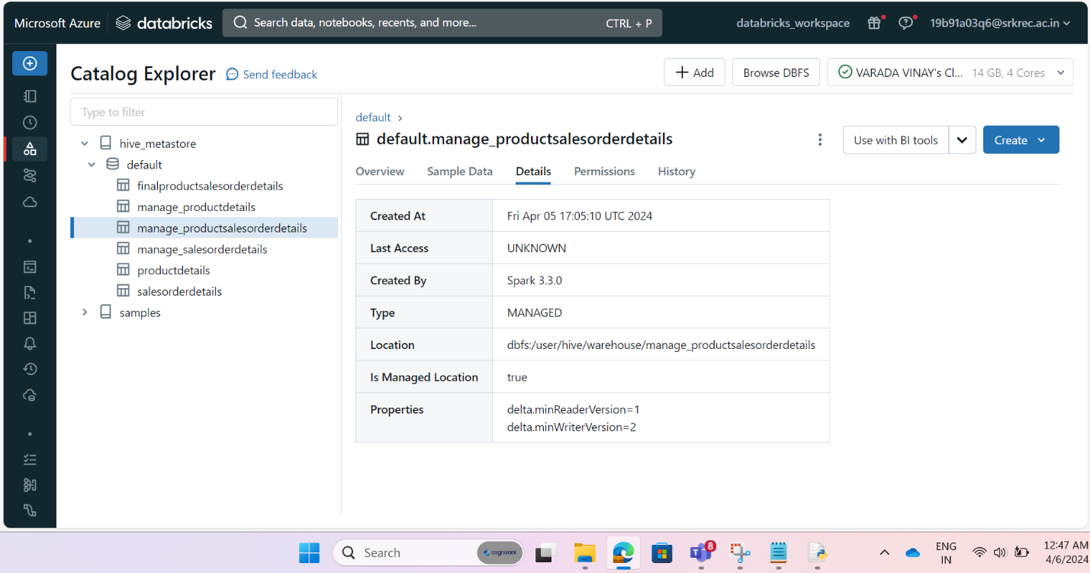

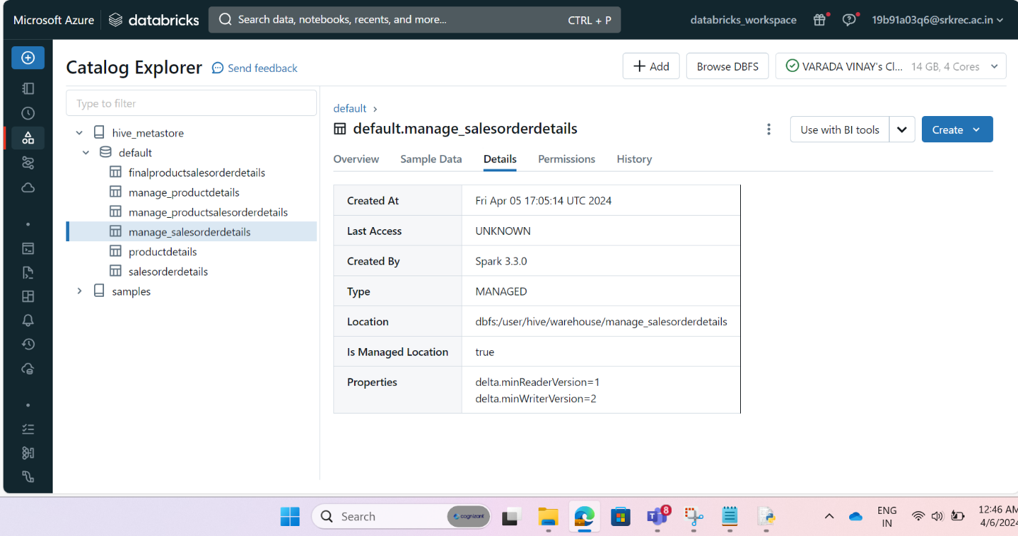

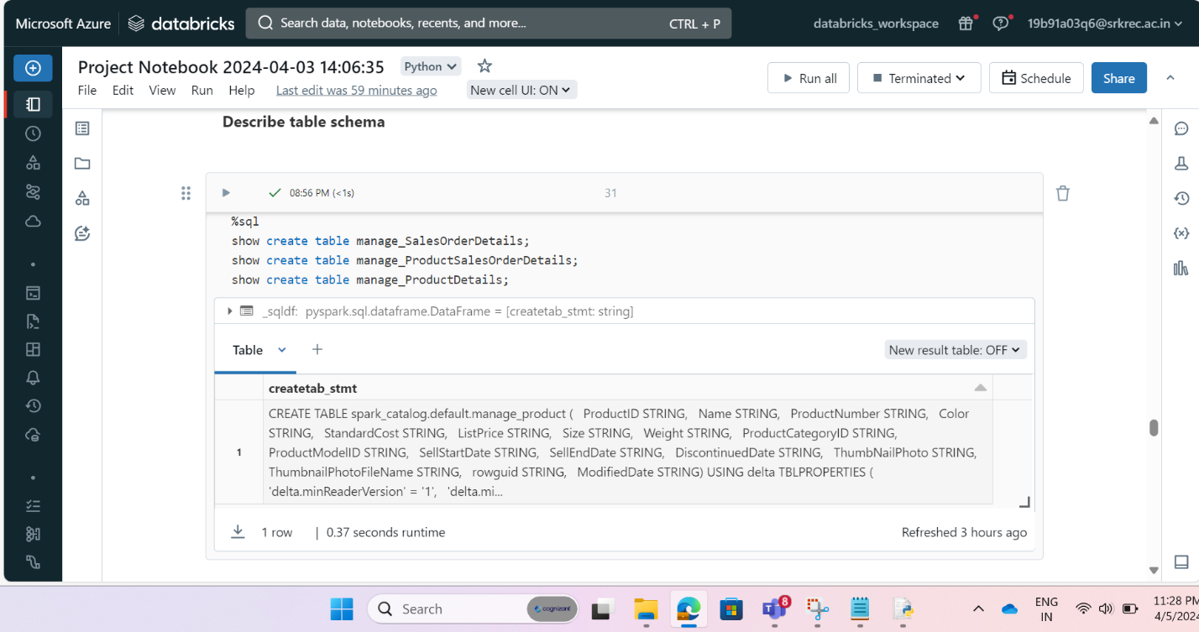

**Creating delta tables (external tables) in data bricks and there results of parquet files in datalake.**

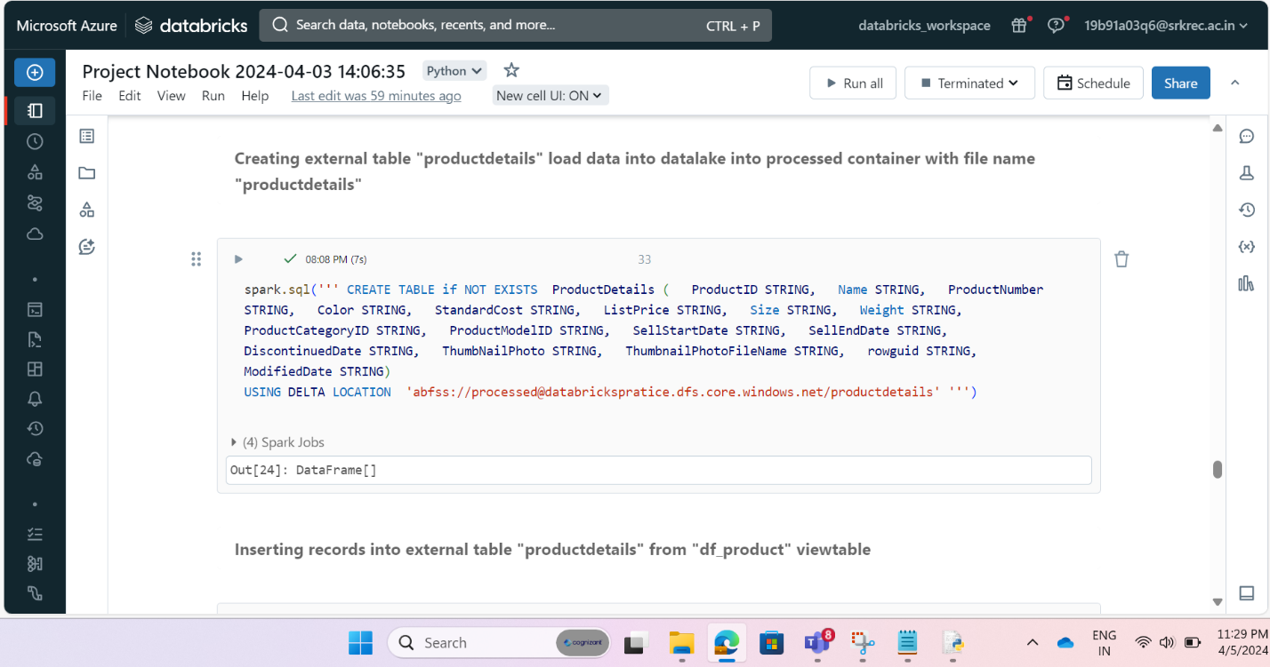

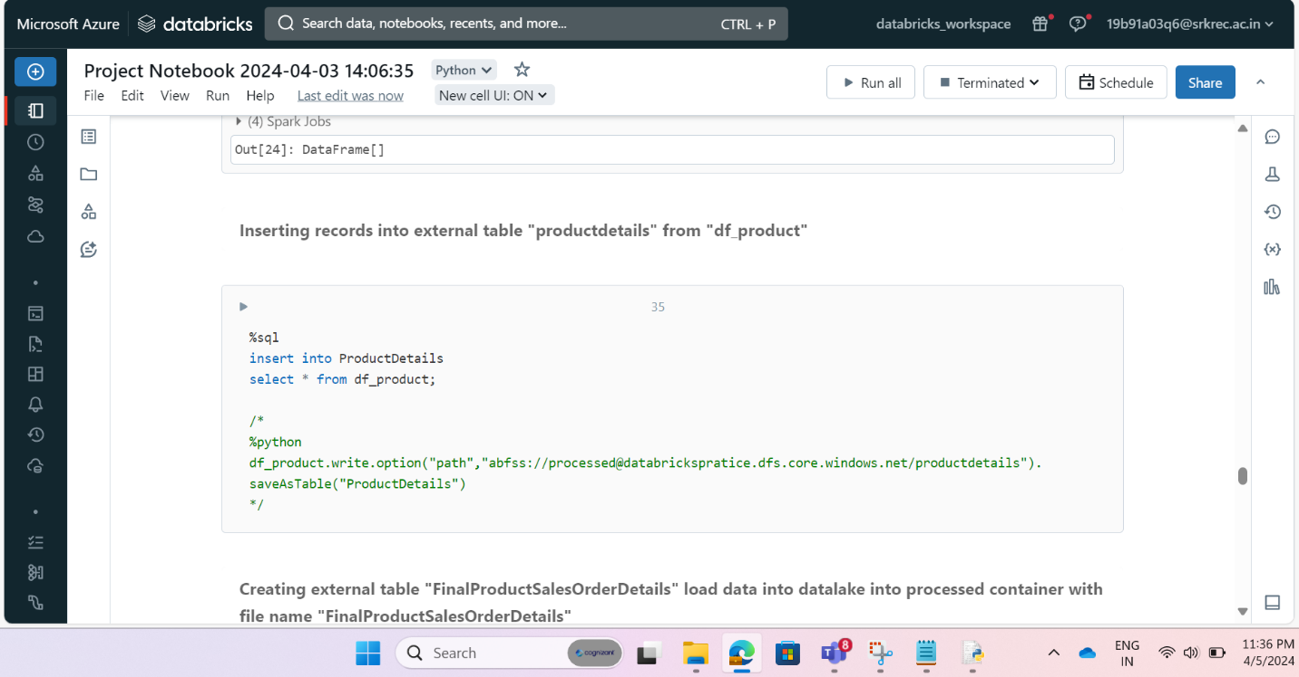

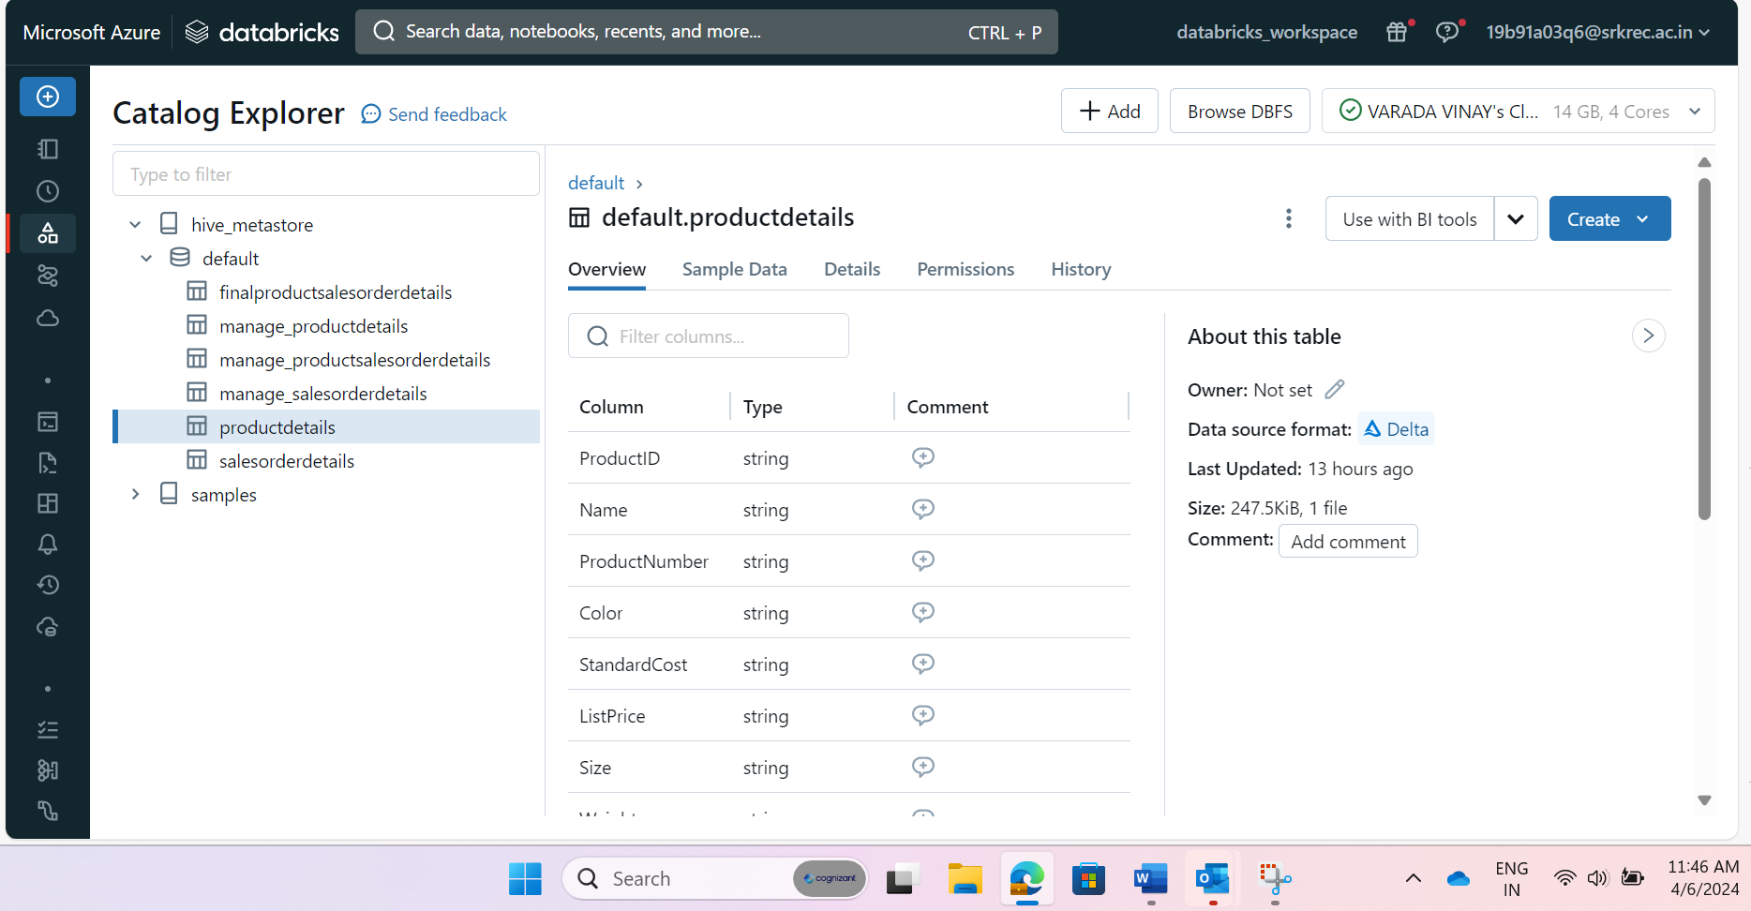

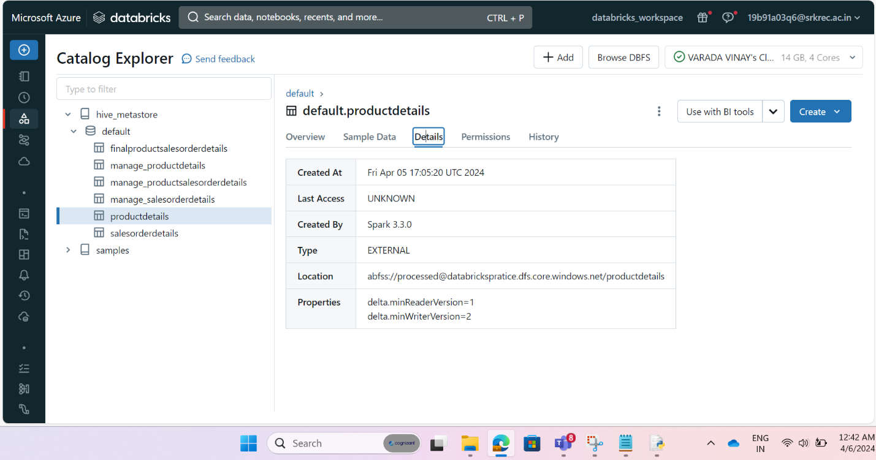

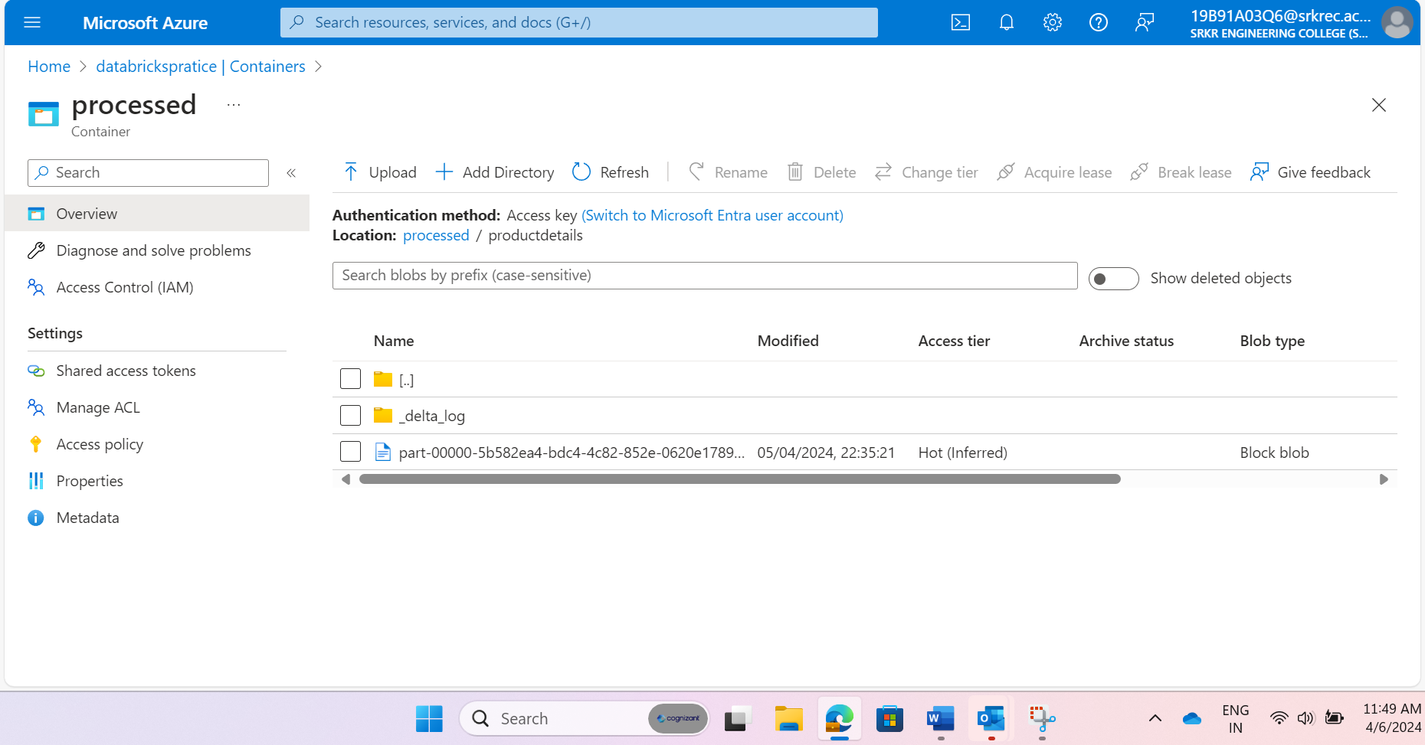

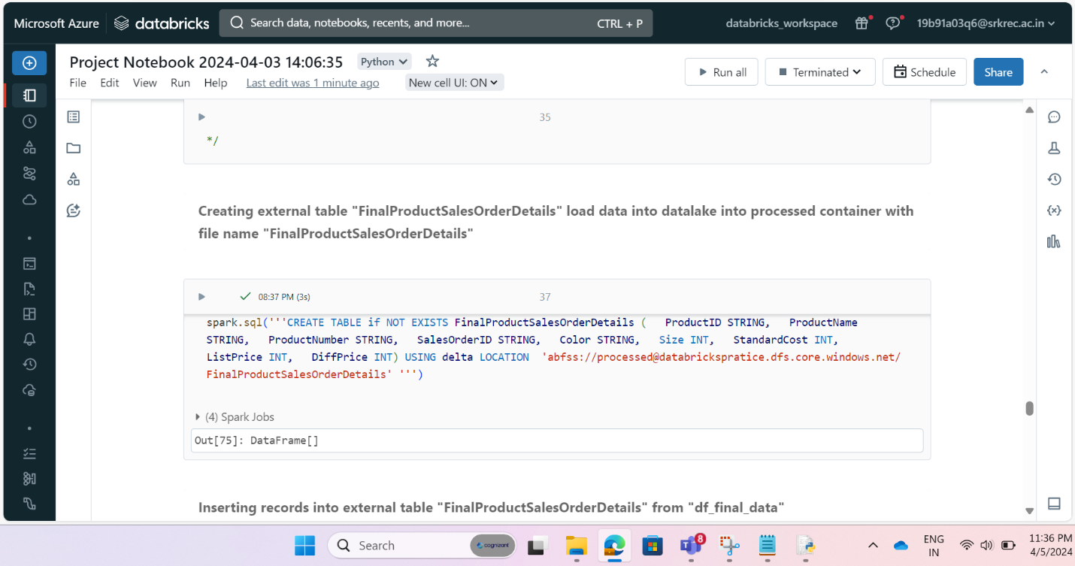

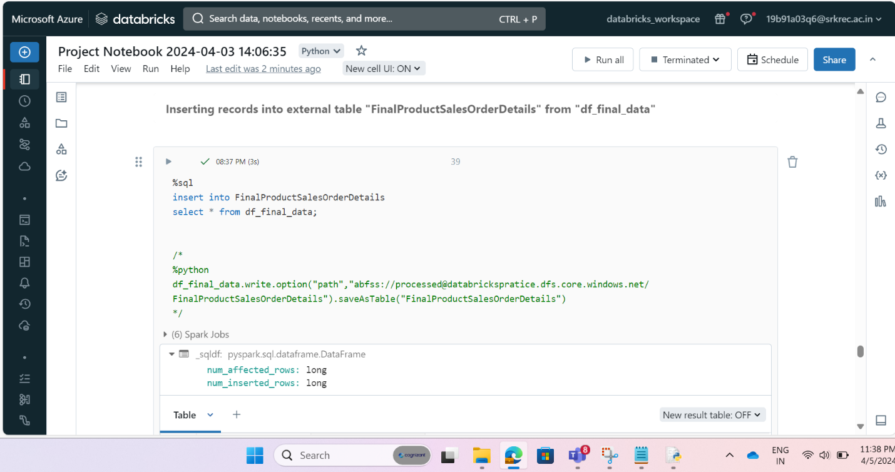

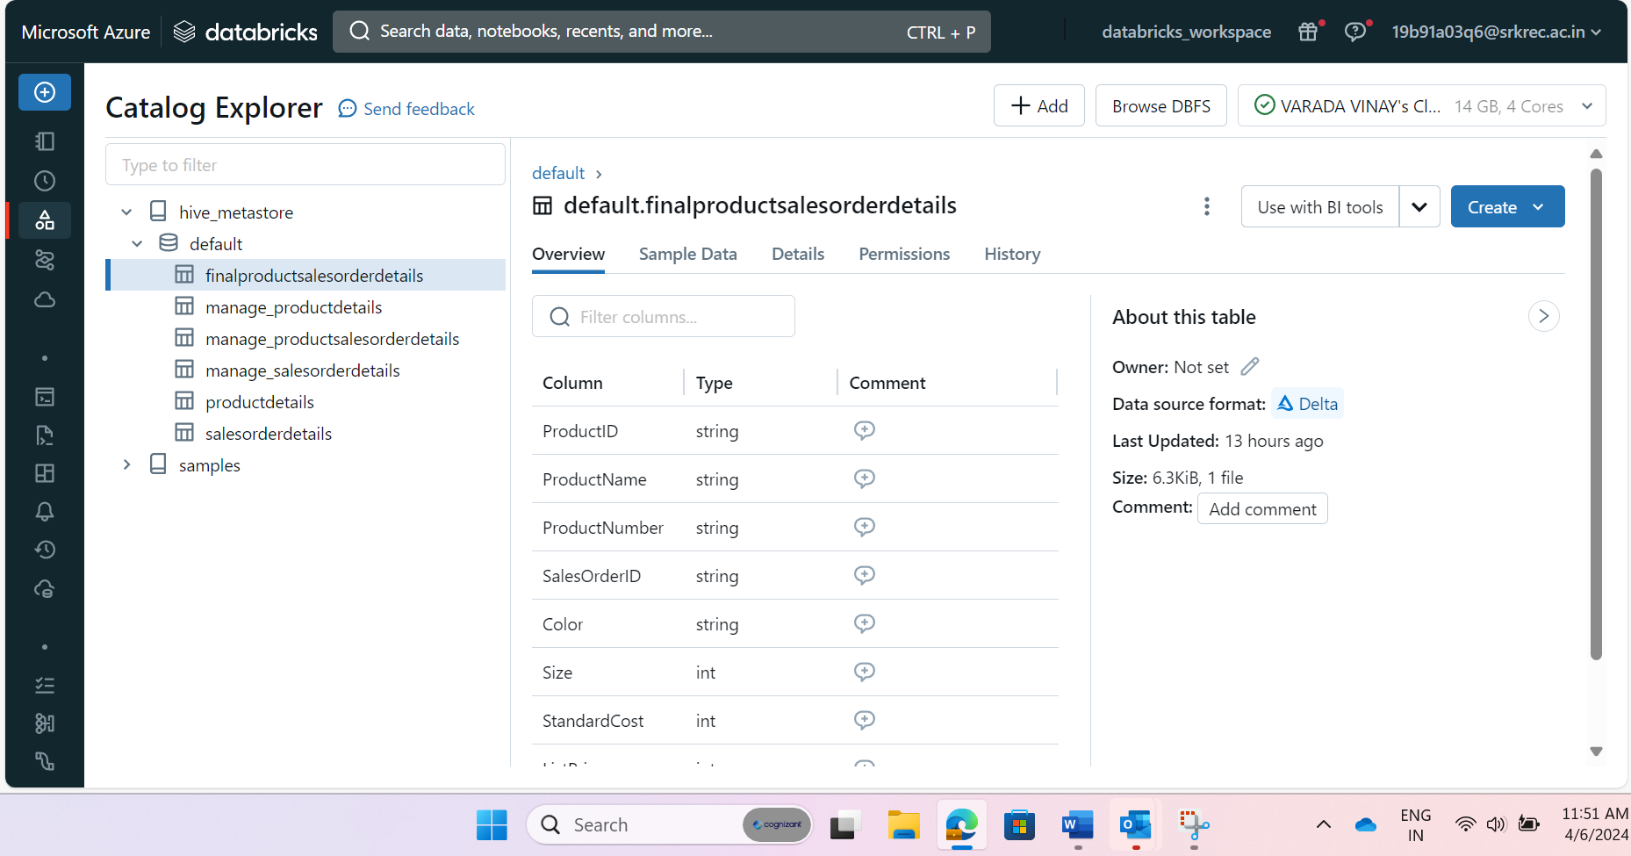

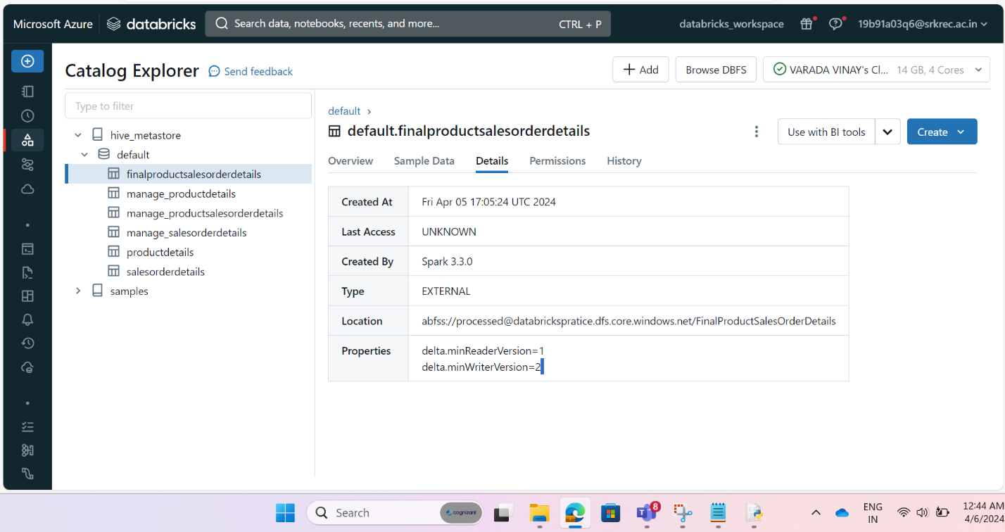

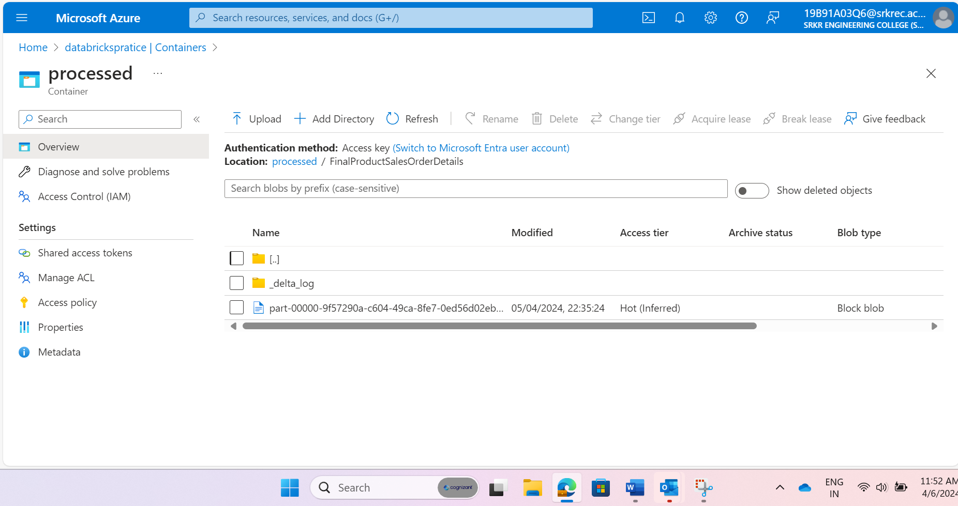

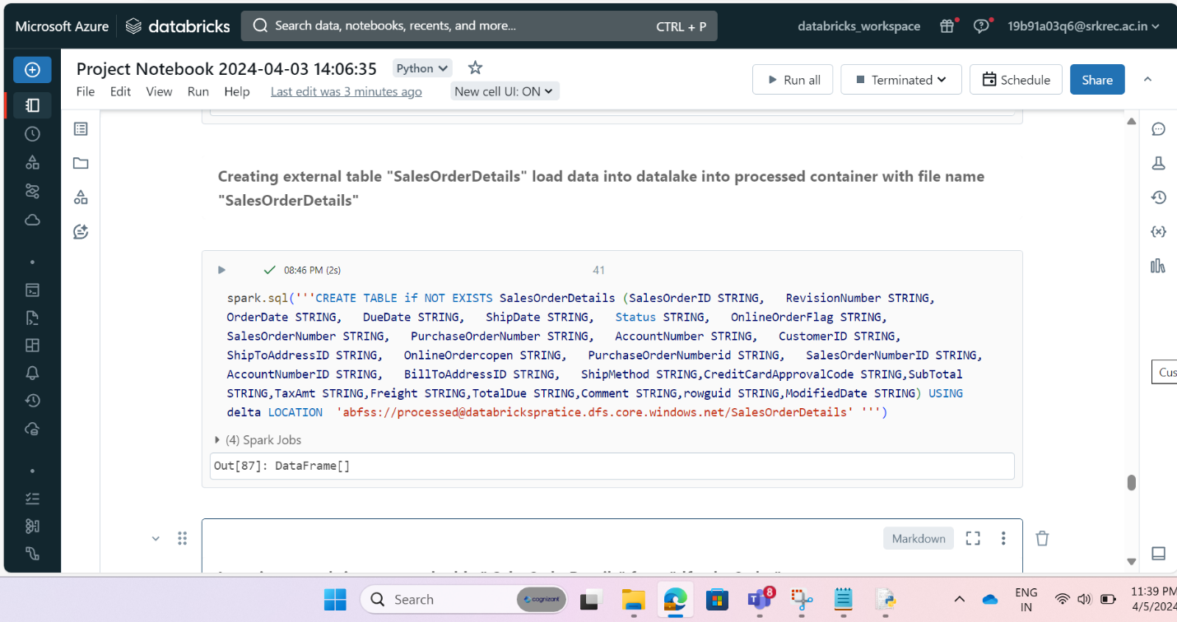

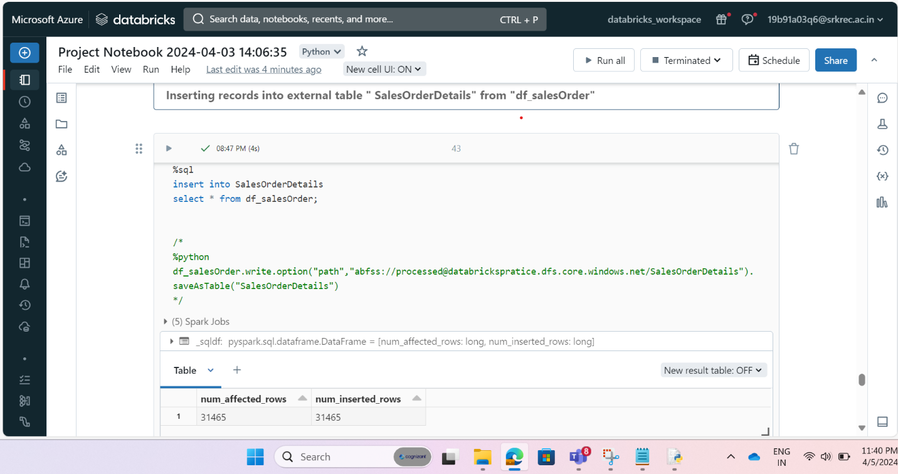

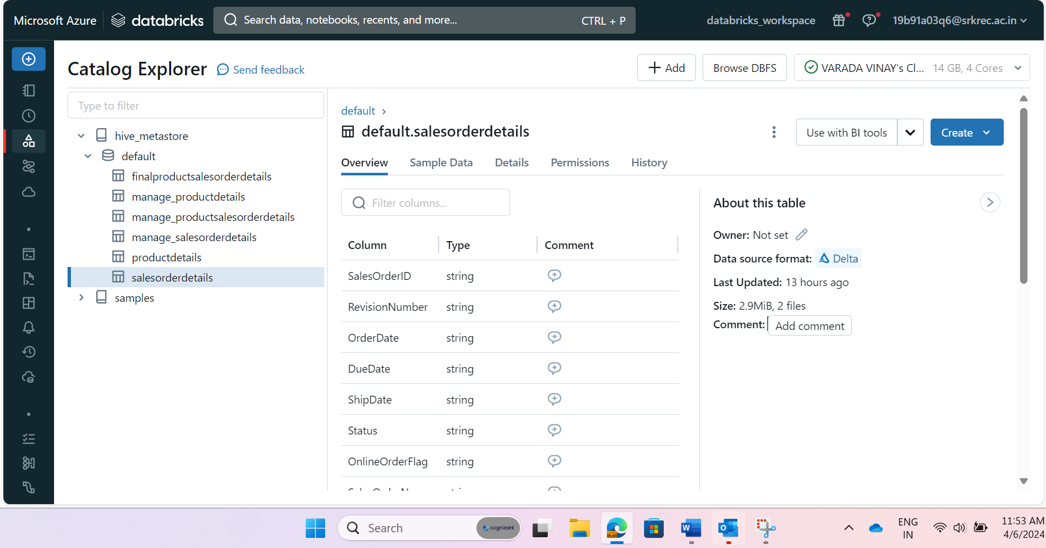

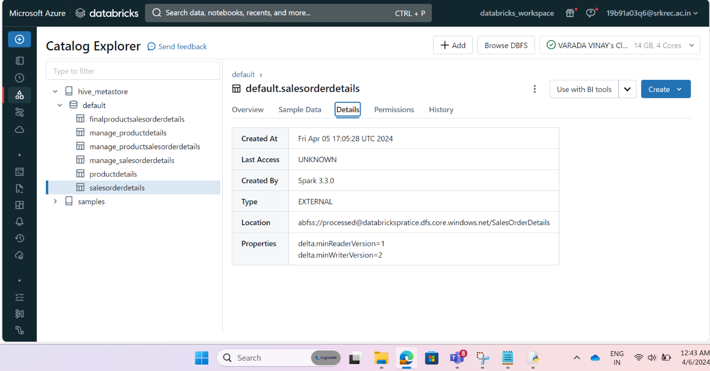

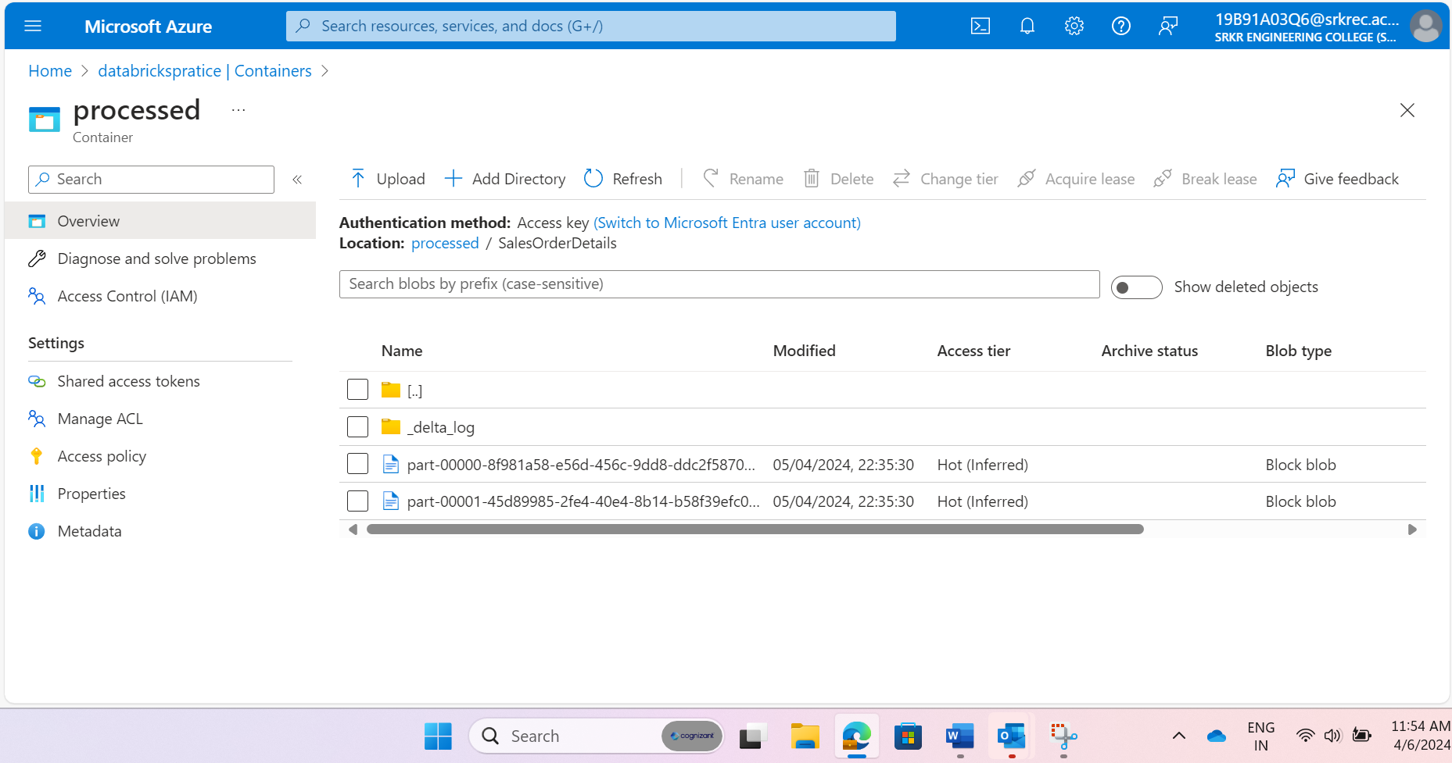

**Pipeline Result on success:**

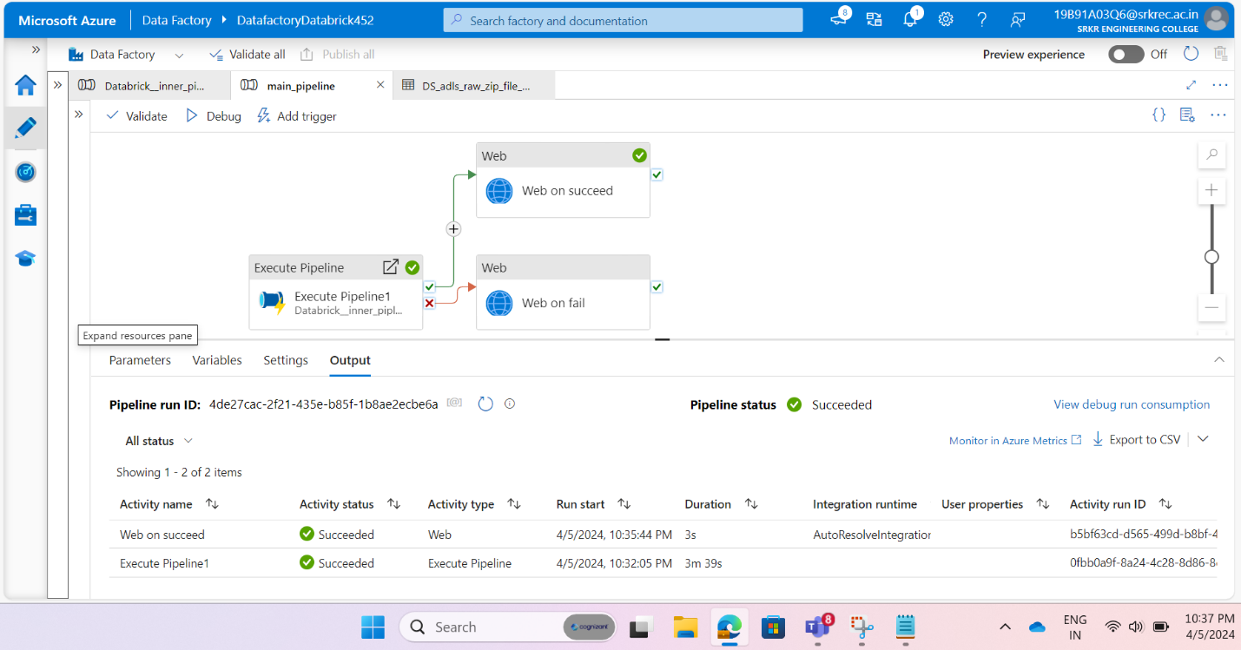

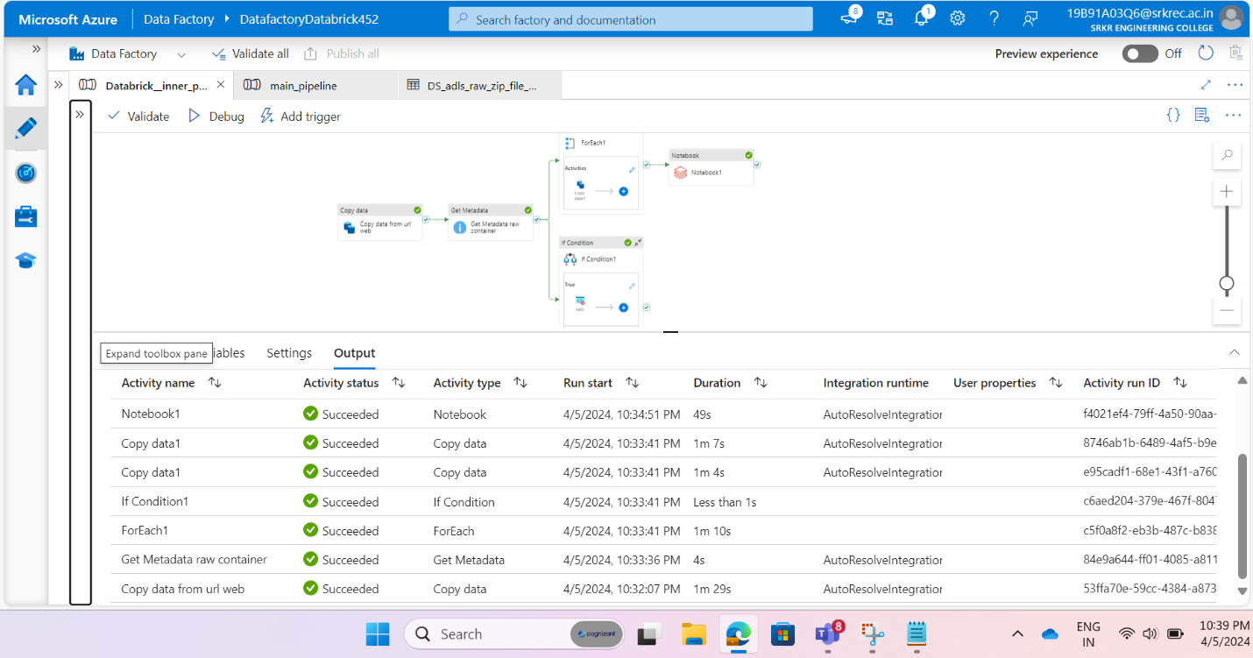

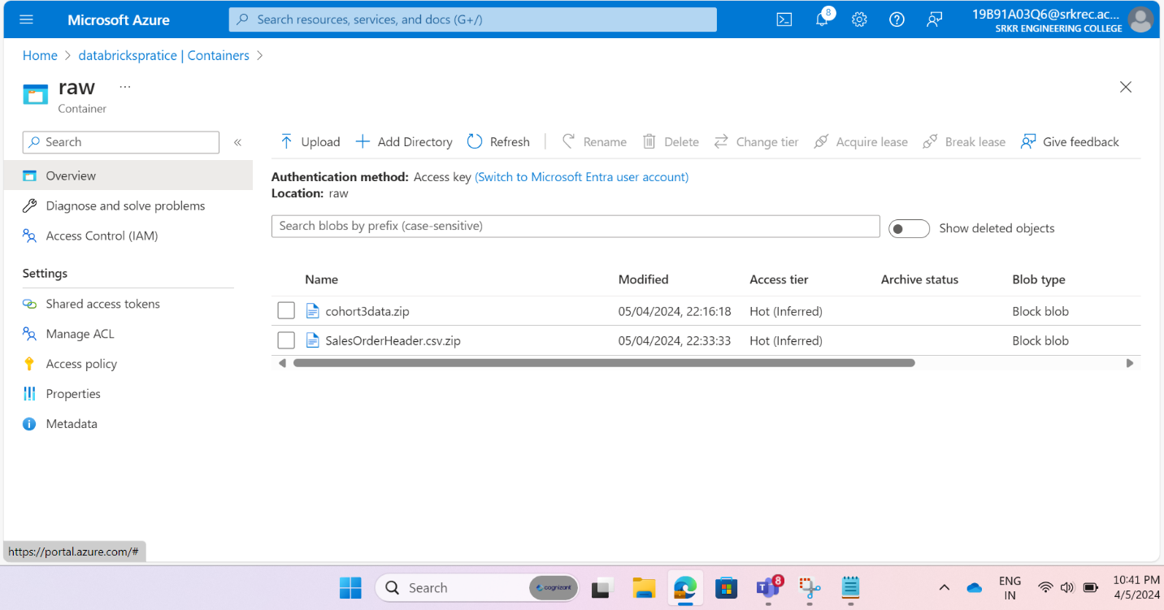

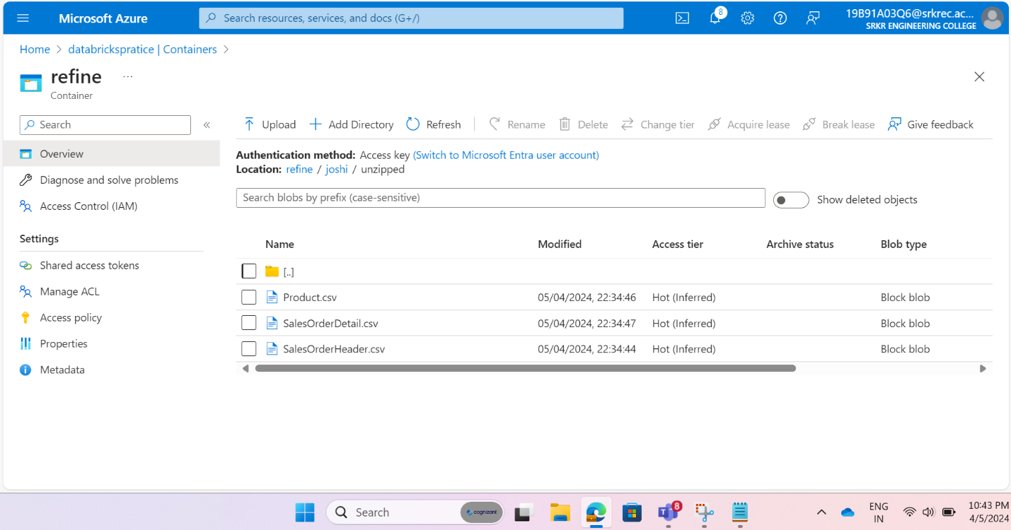

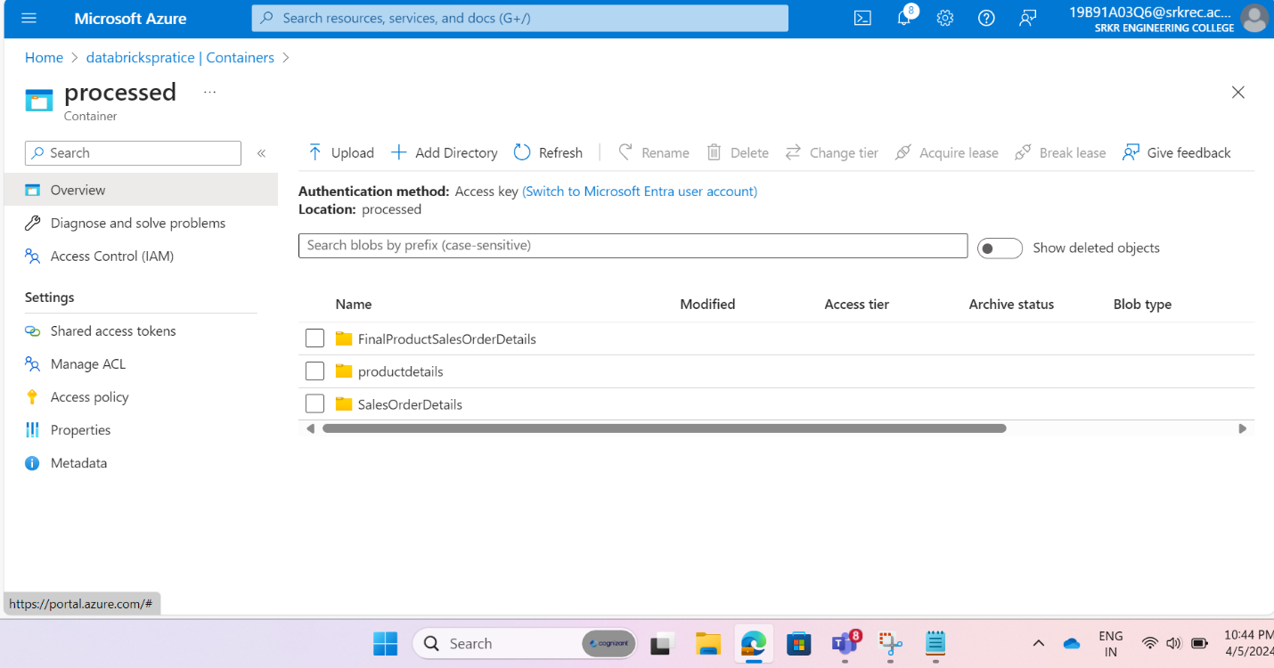

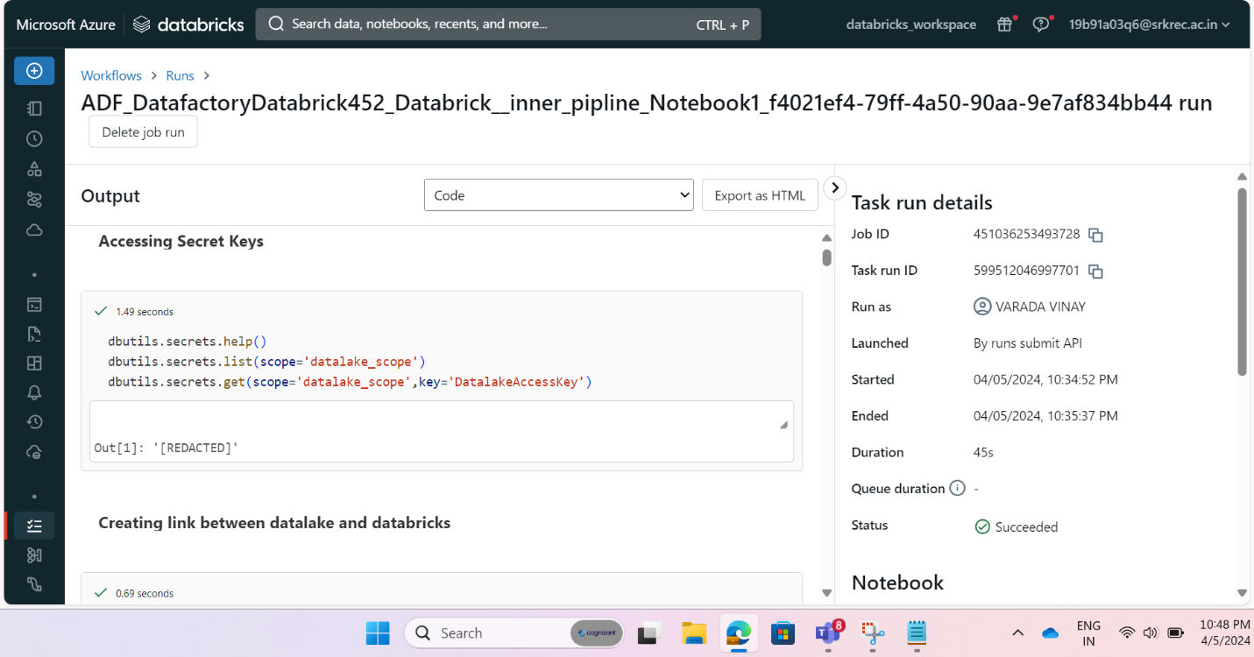

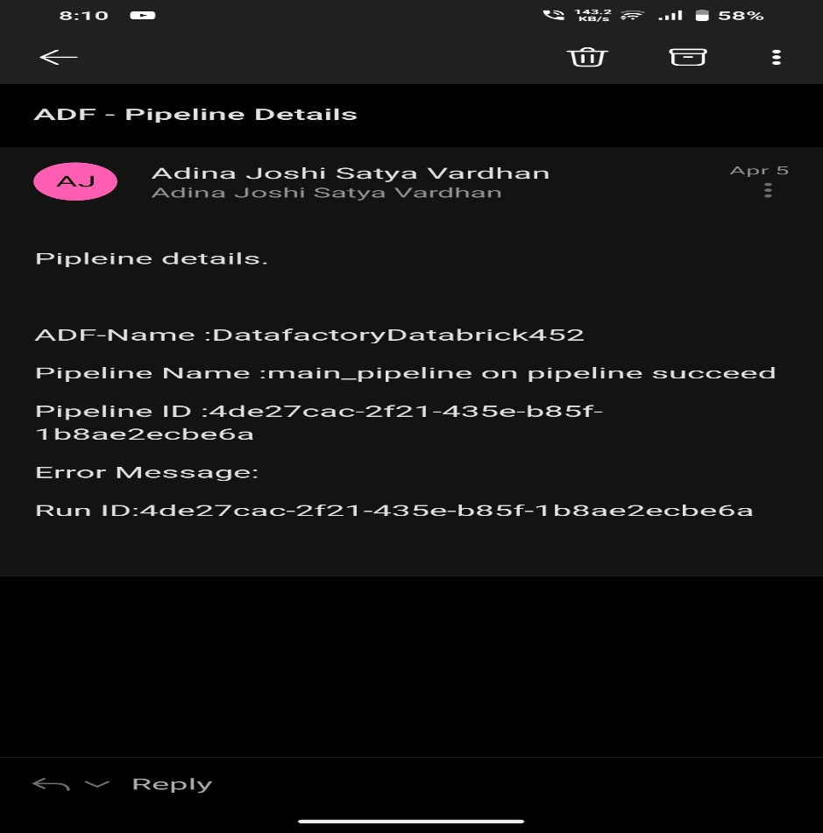

**Mail on pipeline succeed**

**Mail on pipeline failed:**

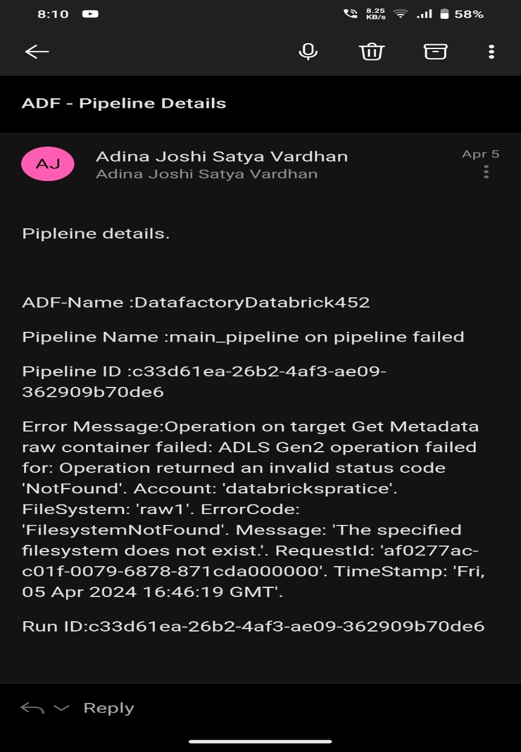

**Visualization:**

